Framework for Interactive Content Generation and Publishing

By

Siddharth Ayer 12BCE175

Yamini Rathod 11BCE078



DEPARTMENT OF COMPUTER SCIENCE ENGINEERING

AHMEDABAD-382481

May 2015

Framework for Interactive Content Generation and Publishing

Major Project

Submitted in partial fulfillment of the requirements

For the degree of

Bachelor of Technology in Computer Science Engineering

By

Siddharth Ayer 12BCE175

Yamini Rathod 11BCE078

Guided By

Dr. Madhuri Bhavsar



DEPARTMENT OF Computer Science Engineering

AHMEDABAD-382481

May 2015

Certificate

This is to certify that the Major Project entitled "Framework for Interactive Content Generation and Publishing" submitted by Siddharth Ayer(12BCE175) and Yamini Rathod (11BCE078 ), towards the partial fulfillment of the requirements for the degree of Bachelor of Technology in Computer Science Engineering of Nirma University, Ahmedabad is the record of work carried out by her under my supervision and guidance. In my opinion, the submitted work has reached a level required for being accepted for examination. The results embodied in this Major Project, to the best of my knowledge, haven't been submitted to any other university or institution for award of any degree or diploma.

Dr. Madhuri Bhavsar,

Asst. Professor and Lab Faculty,

Computer Science Engineering,

Institute of Technology,

Nirma University, Ahemdabad.

Dr. Sanjay Garg

Professor and Head,

Computer Science Engineering,

Institute of Technology,

Nirma University, Ahmedabad.

Acknowledgement

We owe a great many thanks to a great many people who helped and supported us during the completion of this Industry Project.

Our deepest thanks to our guide and head of department at Nirma University, Dr. Madhuri Bhavsar and Dr. Sanjay Garg for guiding and correcting various actions and steps and documents of us with attention and care. They have presented a good amount of attention throughout the project and make necessary correction as and when needed.

We express our thanks to the Principal of Nirma University, Ahmedabad, for extending his support.

We would also thank our Institution and our faculty members without whom this project would have been a distant reality.

* Siddharth Ayer (12BCE175)
* Yamini Rathod (11BCE078)

Abstract

This project is an apparent solution to the problems faced by the organizations in generating and publishing content. The solution is to provide the coupling facility between the tools of generating and publishing, which in turn proposes the new challenges that are related to cross domain functionality, and are by nature hard to accomplish or at least not achievable without complex and sophisticated solutions. The solution is to provide the framework that does the publishing and generation for us. And this solution can be converted into the need if implemented properly. This solution is focused on creating online framework that provides the means of generating interactive content and mechanism to publish the content over the heterogeneous platforms ranging from formal desktop environments to mobile application. This means that the publishing party would provide the source content as input and views that are compatible with the multiple platforms and environments will be available as output. This solution is made from the ground up with the latest technology available and hence it keeps the door for the expansion and extension open. And hence it is more preferable and economical. Also the published content is compatible with the majority of the platforms ranging from desktop systems to the Sandboxed Mobile Application environment. Also the system is capable of publishing content that target device can cache offline. And hence eliminate the need of the continuous communication with our server. The system is accessible from the web enabled device and would have group of users each with different access rights and set of primitive action and responsibility. And according to the criterion set by us, users will be able to access the content. This provision of the content access will be subject to the service agreement which can be decided, and are subject to change or replace. The system can be extended to publish the content in multiple languages depending on the region of their deployment. This enables us in acquiring the variety of consumer from wide demographic regions.

Content

1. Introduction

1.1 Methodology

1.1.1 Rational Unified Process

1.1.2 Purpose

1.1.3 Scope

1.2 Tools Used

1.2.1 Application Architecture: PHP

1.2.2 Web server – WAMP

1.2.3 Development tool –RAD

1.2.4 Database platform – MySQL

1.3 References

1.4 Technologies to be used

1.5 Overview

1.5.1 Existing System

1.5.2 Proposed System

1.5.3 Our plan

2. Literature Review

3. System Design

3.1 Product perspective

3.1.1 Software Interface

3.1.2 Client on Internet

3.1.3 Web Server

3.1.4 Data Base Server

3.1.5 Development End

3.2 Hardware Interface

3.2.1 Minimum requirements

3.2.2 Recommended requirements

3.3 Communication Interface

3.4 Constraints

3.5 Use Case Model Survey

3.5.1 Administrator

3.5.2 Approver

3.5.3 Reviewer

3.5.4 Sales Executive

3.5.5 Publisher

3.5.6 Manger

3.6 Architecture Diagram

3.7 Database Design

3.8 Specific Requirements

3.8.1 Use case reports

3.8.1.1 Administrator

3.8.1.2 Approver

3.8.1.3 Reviewer

3.8.1.4 Manager

3.8.1.5 Publisher

3.8.1.6 Sales Executive

3.8.2 Activity Diagrams

3.8.2.1 Generalized Object insertion diagram

3.8.2.2 Generalized Object editing diagram

3.8.2.3 Generalized Object Deleting diagram

3.8.2.4 Generalized user login Diagram

3.8.2.5 Content publishing diagram

3.8.2.6 Content Approval diagram

3.8.2.7 Content Review diagram

3.8.2.8 Content push staging diagram

3.8.3 Sequence Diagrams

3.8.3.1 User login sequence diagram

3.8.3.2 Add object sequence diagram

3.8.3.3 Edit Object sequence diagram

3.8.3.4 Delete Object sequence diagram

3.8.3.5 Publishing Sequence Diagram

3.8.4 Class Diagram

3.8.5 CRC Index Cards

4. Implementation

4.1 Login

4.1.1 Login Authentication Page

4.1.2 Login Authentication Process

4.2 Database

4.3 Implementation

4.3.1 Main

4.3.2 User Type Management

4.3.3 User Management

4.3.4 Page Management

4.3.5 Page and User Type Management

4.3.6 Module Management

4.3.7 Page and Module Association

4.3.8 Asset Type Management

4.3.9 Asset Management

4.3.10 Asset Type and Module Association

4.3.11 Extension Management

4.3.12 Extension and Asset Type Association

4.3.13 Content Type Management

4.3.14 Content Subtype Management

4.3.15 Content Template Management

4.3.16 Publisher Management

4.3.17 Sponsor Management

4.3.18 Subscription Management

4.3.19 Asset Selection for Product

4.3.20 Product Content Management

4.3.21 Product Management

4.3.22 Product Subscription Management

4.3.23 Product Template Management

4.3.24 Product Staging Management

4.3.25 Manager Dashboard

4.3.26 Sales Executive Dashboard

5. Results and Conclusion

6. References

**Chapter 1**

**Introduction**

## 1.1 Methodology

### 1.1.1 Rational Unified Process

This software engineering process has three branches from all of the generic process models that a standard software engineering project would requires or is entitled to, it also supports regular revisions and it also provides guidelines of “standard practices” in system analysis and design.

This model is best described by following three perspectives:

**Static |** This phase shows the set of actions that are carried out over development period

**Dynamic |** This phase shows an overview of phases that covers major aspects of development

**Practice |** These phases are guidelines that provides the bases of standards that should be followed

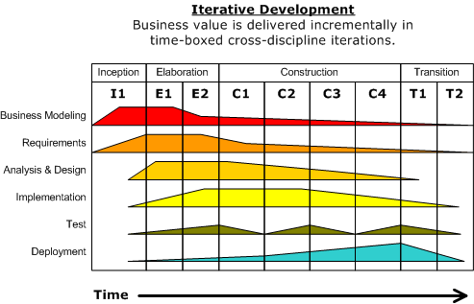

Figure 1Phasese of RUP

**Inception |** The objective of this phase is to provide the outline to the organization for the system. This includes identification of all the factors and entities that will be the part of communication system either to the system or from the system. Collection of this information will help create the business case for the proposed system.

**Elaboration |** This phase mainly encloses the entities related to the bases of understanding the problem, its domain, the framework of architecture and the project plan and most importantly the stakeholder and risk associated with each of them.

**Construction |**Although previous phase may include the activities related to establishing the grounding framework of this project, this phase is actually dedicated to the overall system design, implementation and testing. Parts of the system may be developed in small sized units and finally are coupled together during this phase.

**Transition |**This last phase is concerned with deploying the system to the customer base from the testing and development environment.

### 1.1.2 Purpose

This framework is provided as an intelligent web application to the users who could access it from the wide range of heterogeneous products and environments, and will provides the means of generating the content that they wish to publish and then finally push the generated content to the standard publishing portal that will showcase the outcome of the generated content.

The unique feature of our system is that we will support content interaction, which will increase the utility value of the same content which would otherwise represent the same content but will be less productive.

And hence the framework would relieve the user from using different standard technologies for content generation and other standard technologies to publish same content.

### 1.1.3 Scope

The scope for this project is limited only by the imagination of the organization that uses this. This system can support and publish all kind of media regardless of dependencies that content requires .Though for sake of this major project, a few domains that could utilize this system are as follows,

Educational and training institutes can generate content that is highly interactive and are highly complicated with ease.

Publishing houses can focus onto content generation rather that dealing with complex technologies that can convert this content to publishable form and then actually publishes it on standard platform.1.2 Definitions, Acronyms and Abbreviations

## 1.2 Tools Used

### 1.2.1 Application Architecture: PHP

PHP is a server-side scripting language designed for web development but also used as a general-purpose programming language. PHP code can be simply mixed with HTML code, or it can be used in combination with various template engines and web frameworks. PHP code is usually processed by a PHP interpreter, which is usually implemented as a web server's native module or a Common Gateway Interface (CGI) executable.

After the PHP code is interpreted and executed, the web server sends resulting output to its client, usually in form of a part of the generated web page; for example, PHP code can generate a web page's HTML code, an image, or some other data. PHP has also evolved to include a command-line interface (CLI) capability and can be used in standalone graphical applications.

### 1.2.2 Web server – WAMP

WAMP is an acronym for an archetypal model of web service solution stacks, originally consisting of largely interchangeable components: Windows, the Apache HTTP Server, the MySQL relational database management system, and the PHP programming language. As a solution stack, LAMP is suitable for building dynamic web sites and web applications.

### 1.2.3 Development tool –RAD

Jetbrains PHP Storm is an IDE that can support the development of PHP application by providing code hinting debugging, database visualization and many more.

### 1.2.4 Database platform – MySQL

**MySQL** the world's second most widely used open-source Relational Database Management System (RDBMS).

## 1.3 References

Wikipedia - [*www.wikipedia.com*](http://www.wikipedia.com)

## 1.4 Technologies to be used

* + Php: Server side scripting
  + Bootstrap: Responsive website deign
  + JQuery: Sophisticated JavaScript library
  + MySQL: Relational database system
  + PhPStorm: Rapid application developer

## 1.5 Overview

### 1.5.1 Existing System

No existing system are available, as this the inception of this kind of system.

### 1.5.2 Proposed System

This project is an apparent solution to the problems faced by the organizations in generating and publishing content. The solution is to provide the coupling facility between the tools of generating and publishing, which in turn proposes the new challenges that are related to cross domain functionality, and are by nature hard to accomplish or at least not achievable without complex and sophisticated solutions. The solution is to provide the framework that does the publishing and generation for us. And this solution can be converted into the need if implemented properly. This solution is focused on creating online framework that provides the means of generating interactive content and mechanism to publish the content over the heterogeneous platforms ranging from formal desktop environments to mobile application.

This means that the publishing party would provide the source content as input and views that are compatible with the multiple platforms and environments will be available as output.This solution is made from the ground up with the latest technology available and hence it keeps the door for the expansion and extension open. And hence it is more preferable and economical

Also the published content is compatible with the majority of the platforms ranging from desktop systems to the Sandboxed Mobile Application environment. Also the system is capable of publishing content that target device can cache offline. And hence eliminate the need of the continuous communication with our server.

The system is accessible from the web enabled device and would have group of users each with different access rights and set of primitive action and responsibility. And according to the criterion set by us, users will be able to access the content. This provision of the content access will be subject to the service agreement which can be decided, and are subject to change or replace.

The system can be extended to publish the content in multiple languages depending on the region of their deployment. This enables us in acquiring the variety of consumer from wide demographic regions.

### 1.5.3 Our plan

Release the proposed system at the completion of major project under semester 8.

**Chapter 2**

# Literature Review

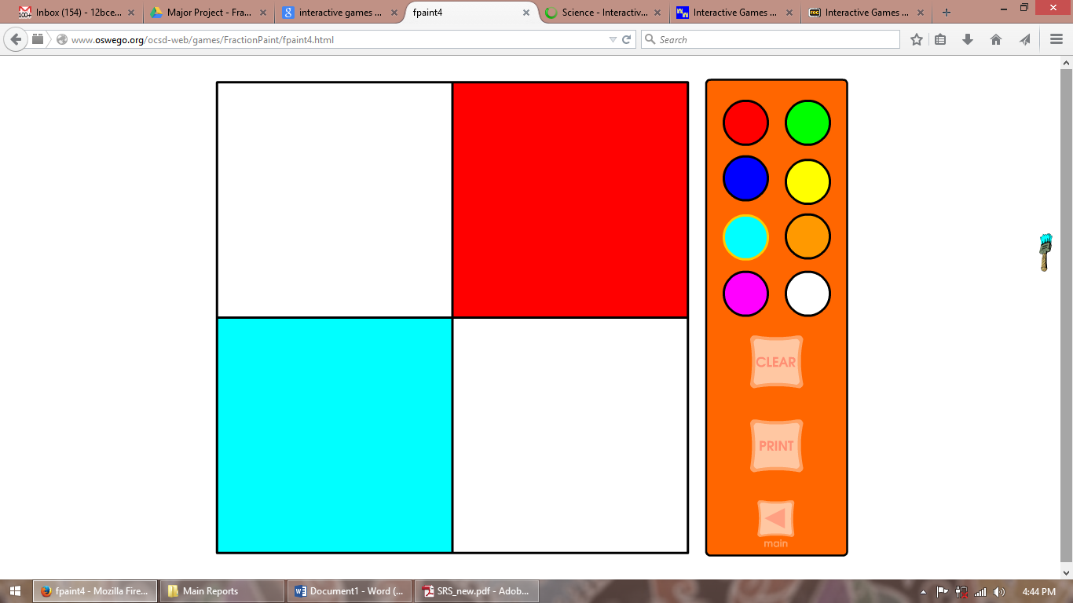

**Name: OSWEGO**

|  |  |
| --- | --- |
| Application type | Static HTML, No database, Non responsive, Non Touch friendly |
| Content Platform | ADOBE FLASH |
| Dynamic Content | No |
| Lacuna | Flash based platform forces this application to be run on the browsers which are having Flash plugins. Major mobile products are dropping support for the Adobe flash due to their Poor battery support and limited interactivity.  Also the site is non-responsive and non-touch friendly making it difficult to use it on mobile and tablet devices.  A very few examples just like shown above are presented and are not updated regularly.  No support from the developers.  No dynamic content and not provision to store user data.  Limited scope as simple HTML is used making it a very basic website. |
| Our Solution | Latest Web animation and event handling JavaScript and HTML5 plugins make development of interactive content easier and it also allows that content to be viewable or accessible on multiple platforms.  The site is made responsive using latest bootstrap framework also different versions of site can be easily exported just by the single version of the code.  Database and Cookie based technologies can store user data and other preferences of site making it tailored for users. |

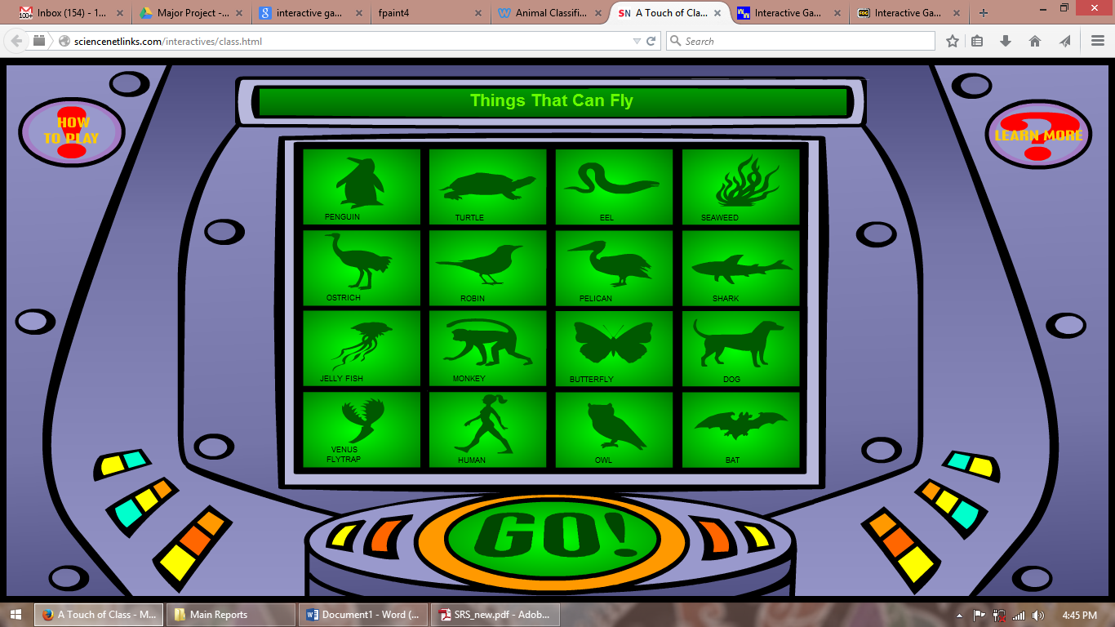

**Name: sciencenetlinks**

|  |  |
| --- | --- |
| Application type | Static HTML, No database, Non responsive, Non Touch friendly |
| Content Platform | ADOBE FLASH |
| Dynamic Content | No |
| Lacuna | Flash based platform forces this application to be run on the browsers which are having Flash plugins. Major mobile products are dropping support for the Adobe flash due to their Poor battery support and limited interactivity.  Also the site is non-responsive and non-touch friendly making it difficult to use it on mobile and tablet devices.  A very large set of examples just like shown above are presented but are not updated regularly.  No dynamic content and not provision to store user data.  Limited scope as simple HTML is used making it a very basic website. |
| Our Solution | Latest Web animation and event handling JavaScript and HTML5 plugins make development of interactive content easier and it also allows that content to be viewable or accessible on multiple platforms.  The site is made responsive using latest bootstrap framework also different versions of site can be easily exported just by the single version of the code.  Database and Cookie based technologies can store user data and other preferences of site making it tailored for users. |

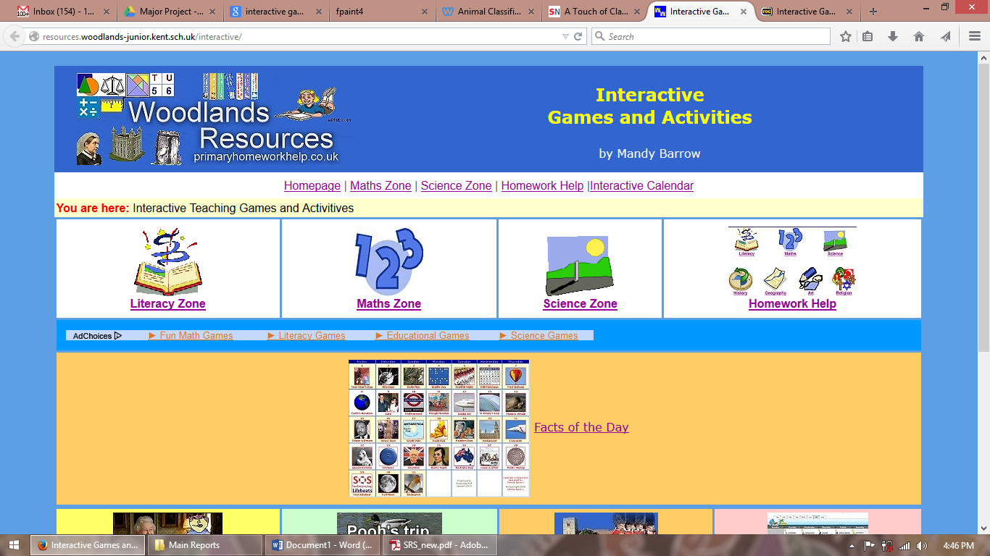

**Name: woodland resources**

|  |  |
| --- | --- |
| Application type | Static HTML, No database, Non responsive, Non Touch friendly |
| Content Platform | ADOBE FLASH |
| Dynamic Content | No |
| Lacuna | Flash based platform forces this application to be run on the browsers which are having Flash plugins. Major mobile products are dropping support for the Adobe flash due to their Poor battery support and limited interactivity.  Also the site is non-responsive and non-touch friendly making it difficult to use it on mobile and tablet devices. Examples on the site are nonfunctional at the time of this literature review.  No dynamic content and not provision to store user data.  Limited scope as simple HTML is used making it a very basic website. |
| Our Solution | Latest Web animation and event handling JavaScript and HTML5 plugins make development of interactive content easier and it also allows that content to be viewable or accessible on multiple platforms.  The site is made responsive using latest bootstrap framework also different versions of site can be easily exported just by the single version of the code.  Database and Cookie based technologies can store user data and other preferences of site making it tailored for users.  Our site will use latest web server technologies and cloud components make It always available. |

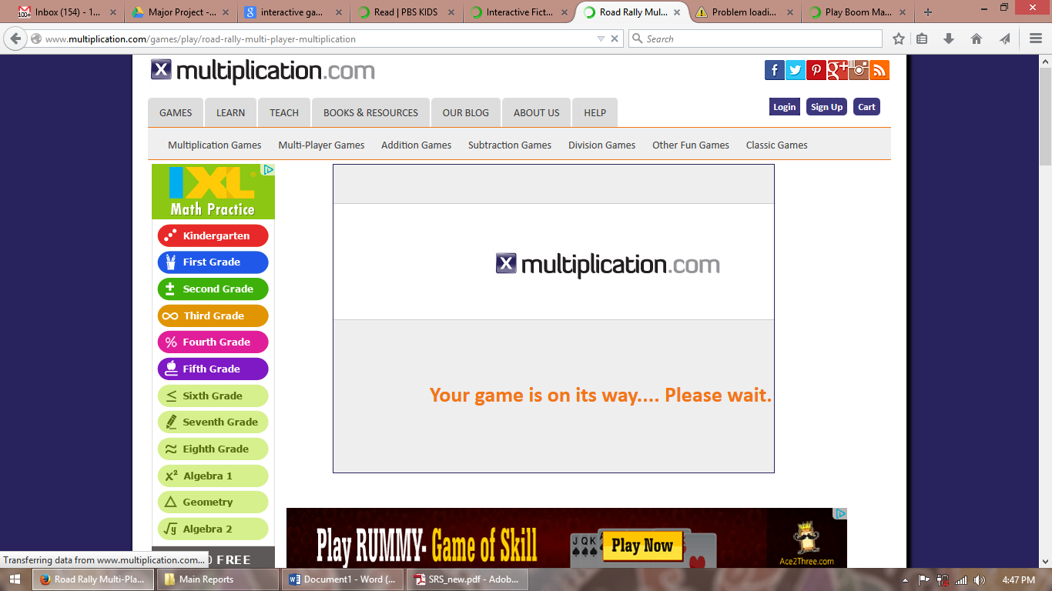

**Name: Multiplication**

|  |  |
| --- | --- |
| Application type | Dynamic(ASP.net), with database, Non responsive, Touch friendly |
| Content Platform | ADOBE FLASH |
| Dynamic Content | yes |
| Lacuna | Flash based platform forces this application to be run on the browsers which are having Flash plugins. Major mobile products are dropping support for the Adobe flash due to their Poor battery support and limited interactivity.  Also the site is non-responsive friendly making it difficult to use it wide variety of devices.  Dynamic content is loaded on the fly also provision to store user data.  Site takes forever to load the content making it basically less usable. |
| Our Solution | Latest Web animation and event handling JavaScript and HTML5 plugins make development of interactive content easier and it also allows that content to be viewable or accessible on multiple platforms.  The site is made responsive using latest bootstrap framework also different versions of site can be easily exported just by the single version of the code.  Latest Ajax technologies can make site loading more efficient. |

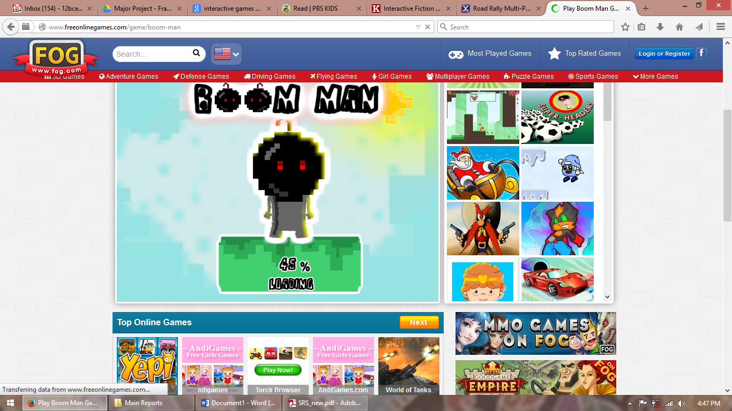

**Name: FOG**

|  |  |
| --- | --- |
| Application type | Dynamic(ASP.net), with database, Non responsive, Non Touch friendly |
| Content Platform | ADOBE FLASH |
| Dynamic Content | No |
| Lacuna | Flash based platform forces this application to be run on the browsers which are having Flash plugins. Major mobile products are dropping support for the Adobe flash due to their Poor battery support and limited interactivity.  Also the site is non-responsive and non-touch friendly making it difficult to use it on mobile and tablet devices.  Dynamic content is loaded on the fly also provision to store user data.  Site heavily dependent on advertisements for its functioning making it less attractive. |
| Our Solution | Latest Web animation and event handling JavaScript and HTML5 plugins make development of interactive content easier and it also allows that content to be viewable or accessible on multiple platforms.  The site is made responsive using latest bootstrap framework also different versions of site can be easily exported just by the single version of the code.  The sponsor mechanism will let us make revenue to publish the content without making a mess out of irritating online advertisement. |

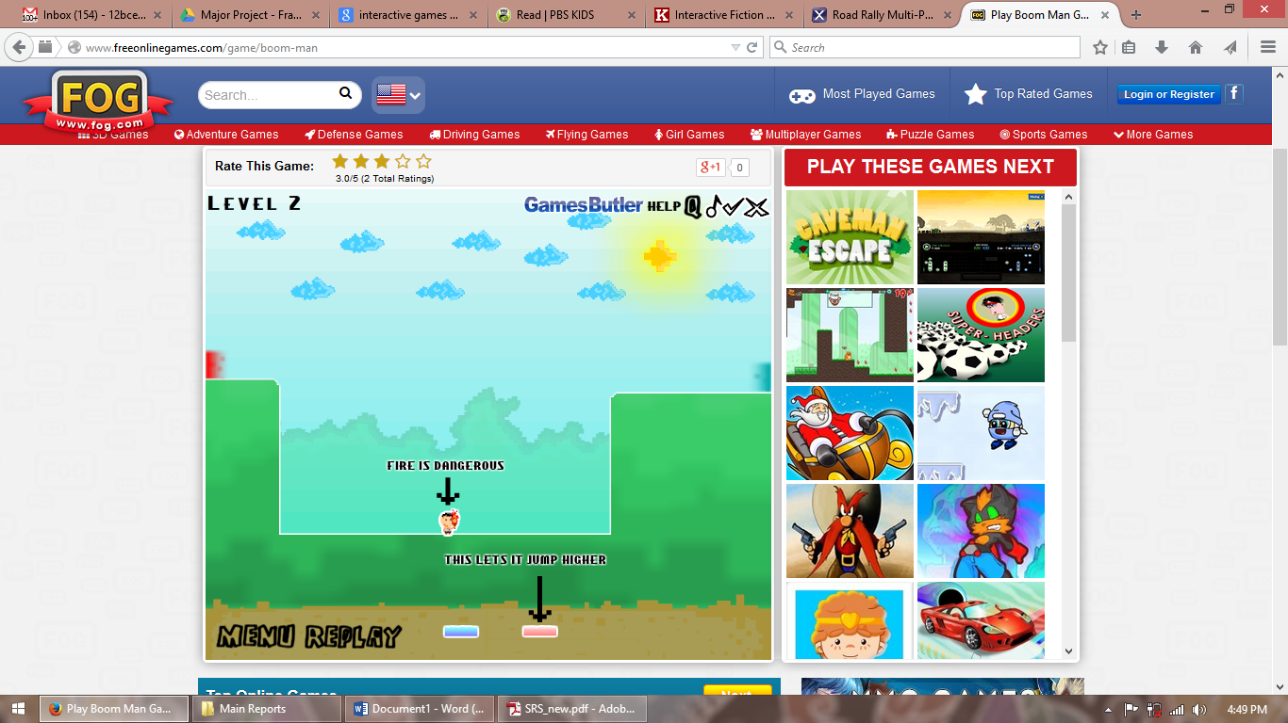

**Name: FOG**

|  |  |
| --- | --- |
| Application type | Dynamic(ASP.net), with database, Non responsive, Non Touch friendly |
| Content Platform | ADOBE FLASH |
| Dynamic Content | No |
| Lacuna | Flash based platform forces this application to be run on the browsers which are having Flash plugins. Major mobile products are dropping support for the Adobe flash due to their Poor battery support and limited interactivity.  Also the site is non-responsive and non-touch friendly making it difficult to use it on mobile and tablet devices.  Dynamic content is loaded on the fly also provision to store user data.  Site heavily dependent on advertisements for its functioning making it less attractive.  Site uses complicated interactions which are rather confusing to certain age groups. |
| Our Solution | Latest Web animation and event handling JavaScript and HTML5 plugins make development of interactive content easier and it also allows that content to be viewable or accessible on multiple platforms.  A well though ways to interaction mechanism and a team of designers for making interaction more easy and beautiful. |

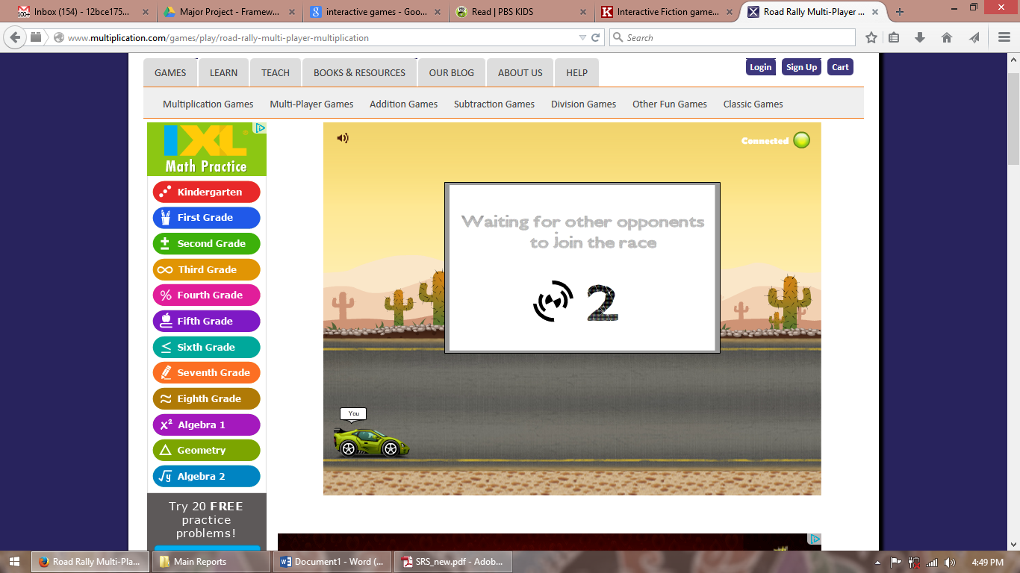

**Name: multiplication**

|  |  |
| --- | --- |
| Application type | Dynamic(ASP.net), withdatabase, Non responsive, Non Touch friendly |
| Content Platform | ADOBE FLASH |
| Dynamic Content | No |
| Lacuna | Flash based platform forces this application to be run on the browsers which are having Flash plugins. Major mobile products are dropping support for the Adobe flash due to their Poor battery support and limited interactivity.  Also the site is non-responsive and non-touch friendly making it difficult to use it on mobile and tablet devices.  Dynamic content is loaded on the fly also provision to store user.  Site provides the multiplayer feature on the cost of too long waiting and queuing time. |
| Our Solution | Latest Web animation and event handling JavaScript and HTML5 plugins make development of interactive content easier and it also allows that content to be viewable or accessible on multiple platforms.  The site is made responsive using latest bootstrap framework also different versions of site can be easily exported just by the single version of the code.  Multiplayer features are allowed using separate Ajax apis tailored to move data efficiently between users. |

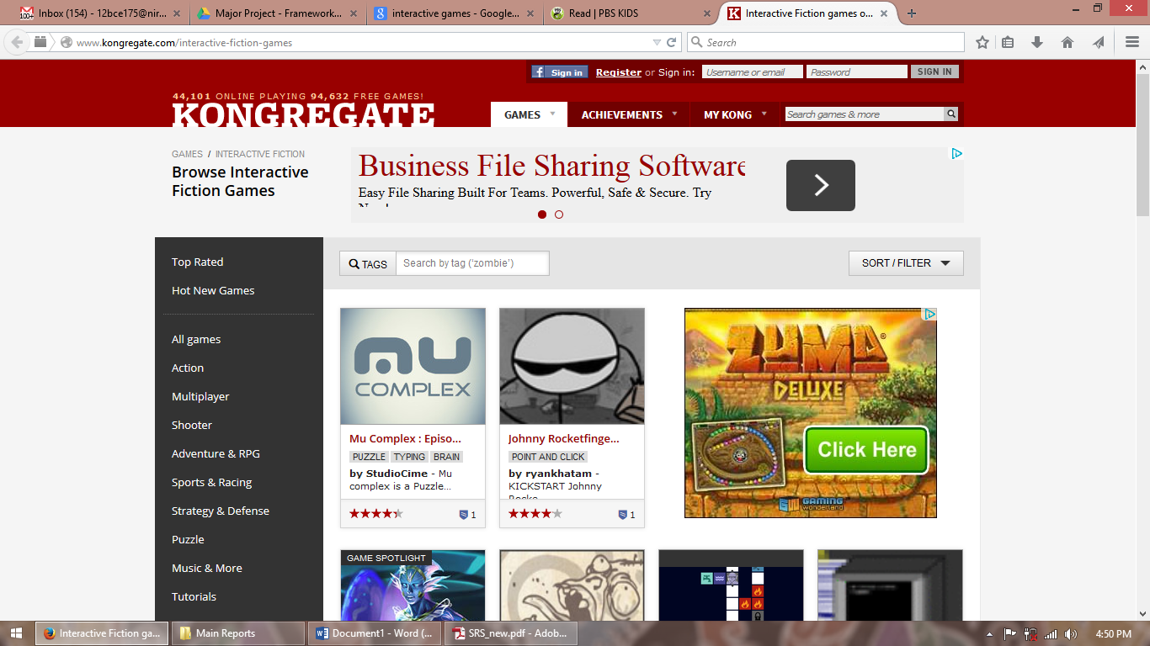

**Name: KONGRGATE**

|  |  |
| --- | --- |
| Application type | Dynamic(Php), database, Non responsive, Non Touch friendly |
| Content Platform | ADOBE FLASH |
| Dynamic Content | Yes |
| Lacuna | Flash based platform forces this application to be run on the browsers which are having Flash plugins. Major mobile products are dropping support for the Adobe flash due to their Poor battery support and limited interactivity.  Also the site is non-responsive and non-touch friendly making it difficult to use it on mobile and tablet devices.  Dynamic content is loaded on the fly also provision to store user data.  Big advertisements makes this site less attractive. |
| Our Solution | Latest Web animation and event handling JavaScript and HTML5 plugins make development of interactive content easier and it also allows that content to be viewable or accessible on multiple platforms.  The site is made responsive using latest bootstrap framework also different versions of site can be easily exported just by the single version of the code.  The sponsor mechanism will let us make revenue to publish the content without making a mess out of irritating online advertisement. |

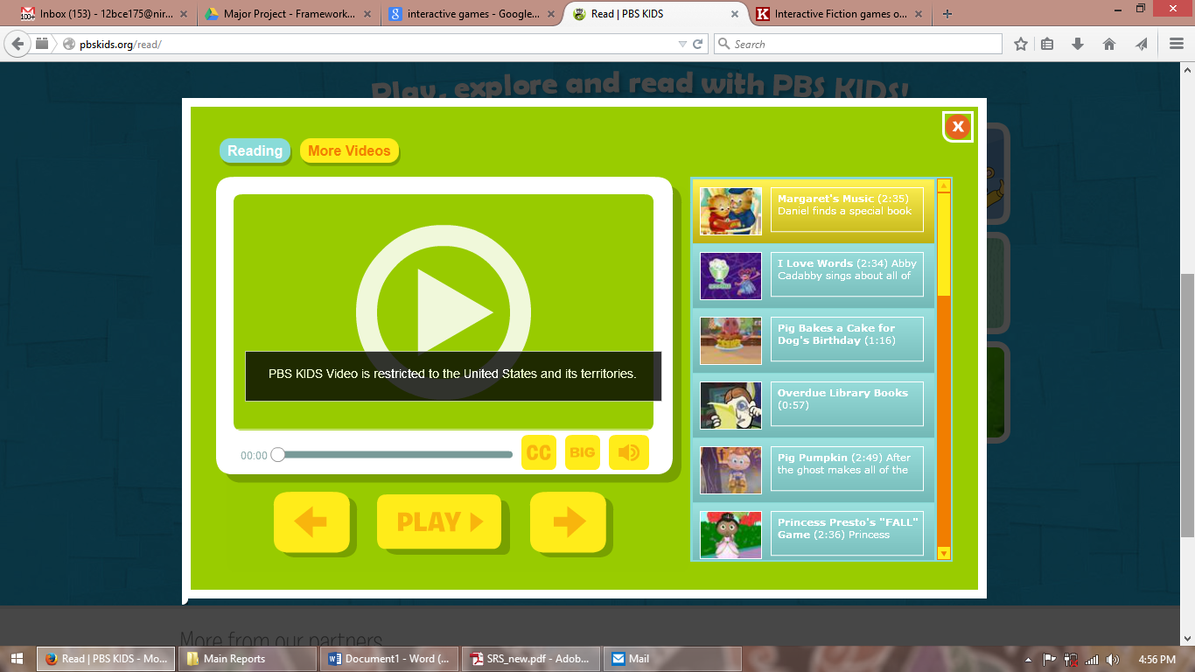

**Name: pbskinds**

|  |  |
| --- | --- |
| Application type | Dynamic(ASP.net), database, Non responsive, Non Touch friendly |
| Content Platform | ADOBE FLASH |
| Dynamic Content | No |
| Lacuna | Flash based platform forces this application to be run on the browsers which are having Flash plugins. Major mobile products are dropping support for the Adobe flash due to their Poor battery support and limited interactivity.  Also the site is non-responsive and non-touch friendly making it difficult to use it on mobile and tablet devices.  Dynamic content is loaded on the fly also provision to store user data.  The site is region locked making it available to only few users. |
| Our Solution | Latest Web animation and event handling JavaScript and HTML5 plugins make development of interactive content easier and it also allows that content to be viewable or accessible on multiple platforms.  The site is made responsive using latest bootstrap framework also different versions of site can be easily exported just by the single version of the code.  The content will be published online with the cloud technologies and we will make sure that our content is available to all who would like to access it without any region boundaries. |

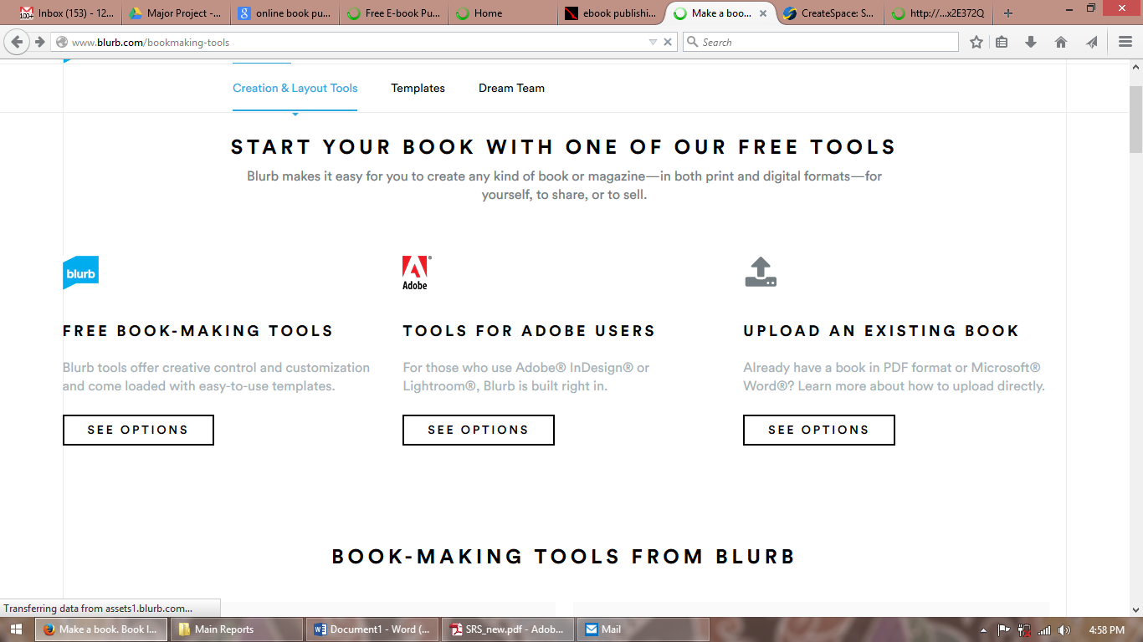

**Name: blurb**

|  |  |
| --- | --- |
| Application type | Dynamic(ASP.net), database, responsive, Touch friendly |
| Content Platform | Custom |
| Dynamic Content | No |
| Lacuna | Site uses custom platform which is fine if content never leaves the site environment.  Dynamic content is loaded on the fly also provision to store user data.  The site provides the tools to create the content but these tools are only offline and they cannot create interactive content. |
| Our Solution | The content generated by our site will be in the standard open format that can be accessed on the wide variety of devices without any dependencies with our framework or tools.  All the tools that we create using this framework are always online and can be accessed from anywhere using any device. |

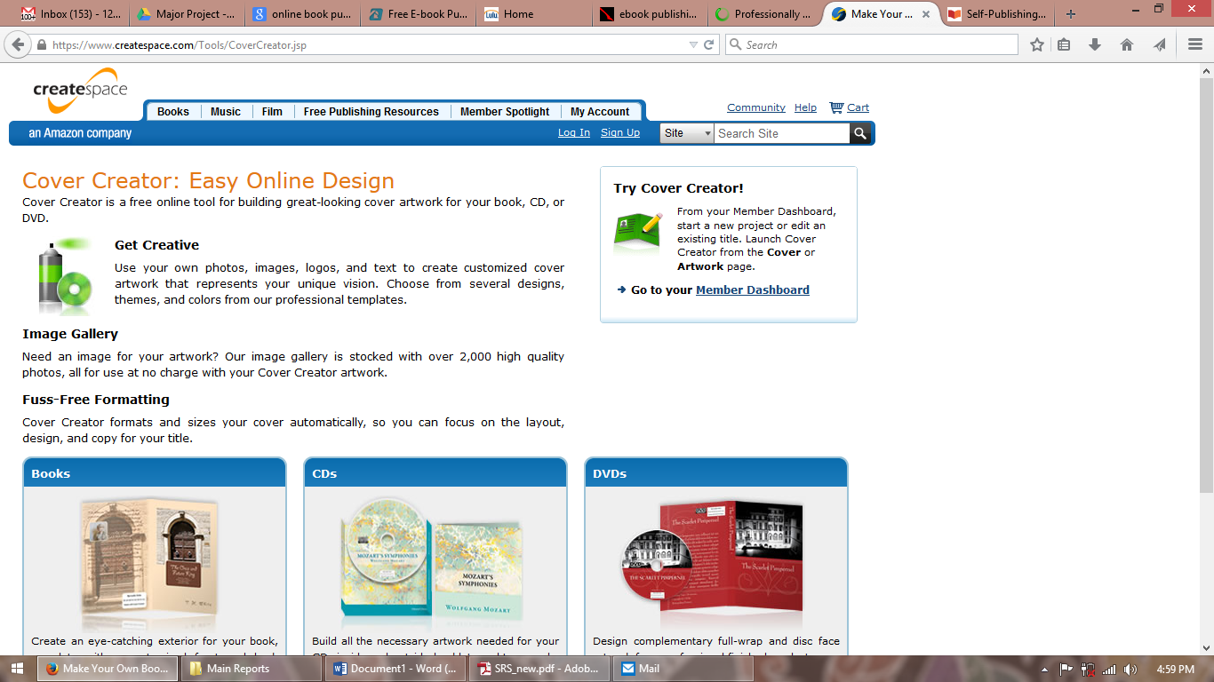

**Name: Createspace**

|  |  |
| --- | --- |
| Application type | Dynamic(ASP.net), database, non-responsive, non-Touch friendly |
| Content Platform | PDF |
| Dynamic Content | No |
| Lacuna | Site use PDF as the content platform making it limited to the features that PDF can support.  Also the site is non-responsive and non-touch friendly making it difficult to use it on mobile and tablet devices.  Dynamic content is loaded on the fly also provision to store user data. |
| Our Solution | The content generated by our site will be in the standard open format that can be accessed on the wide variety of devices without any dependencies with our framework or tools.  Also this format will support that advanced interaction features making it more valuable and engaging. |

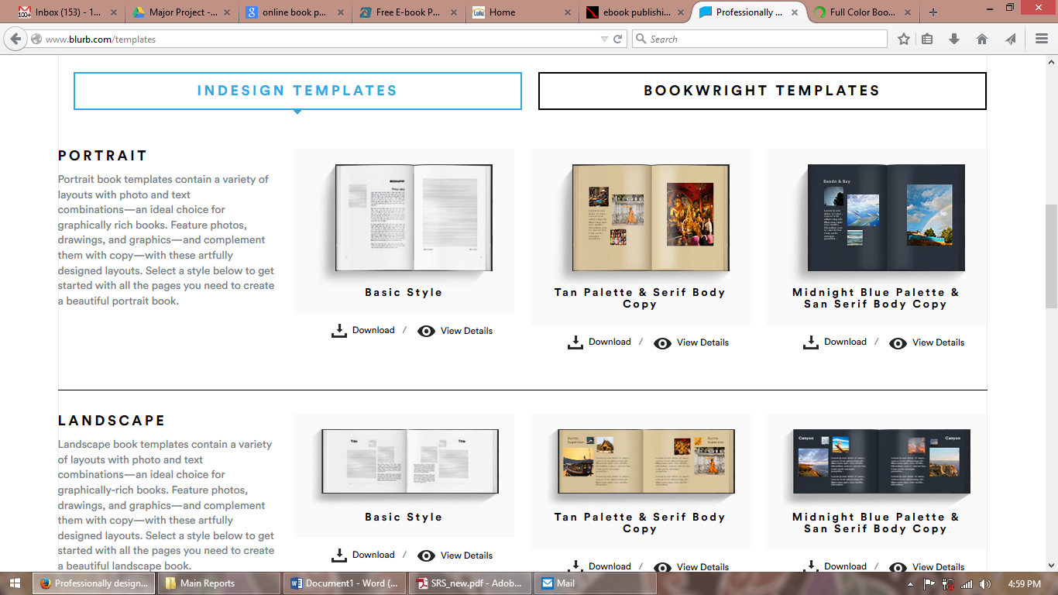

**Name: blurb**

|  |  |
| --- | --- |
| Application type | Dynamic(ASP.net), database, responsive, Touch friendly |
| Content Platform | Custom |
| Dynamic Content | No |
| Lacuna | Site uses custom platform which is fine if content never leaves the site environment.  Dynamic content is loaded on the fly also provision to store user data.  The site provides the tools to create the content but these tools are only offline and they cannot create interactive content.  Also the site has a very limited set of template that user can utilize to create the content. |
| Our Solution | The content generated by our site will be in the standard open format that can be accessed on the wide variety of devices without any dependencies with our framework or tools.  Also this format will support that advanced interaction features making it more valuable and engaging.  Our set to technologies are very customizable and also flexible enough that let us create unlimited set of templates regardless of the technologies we use. |

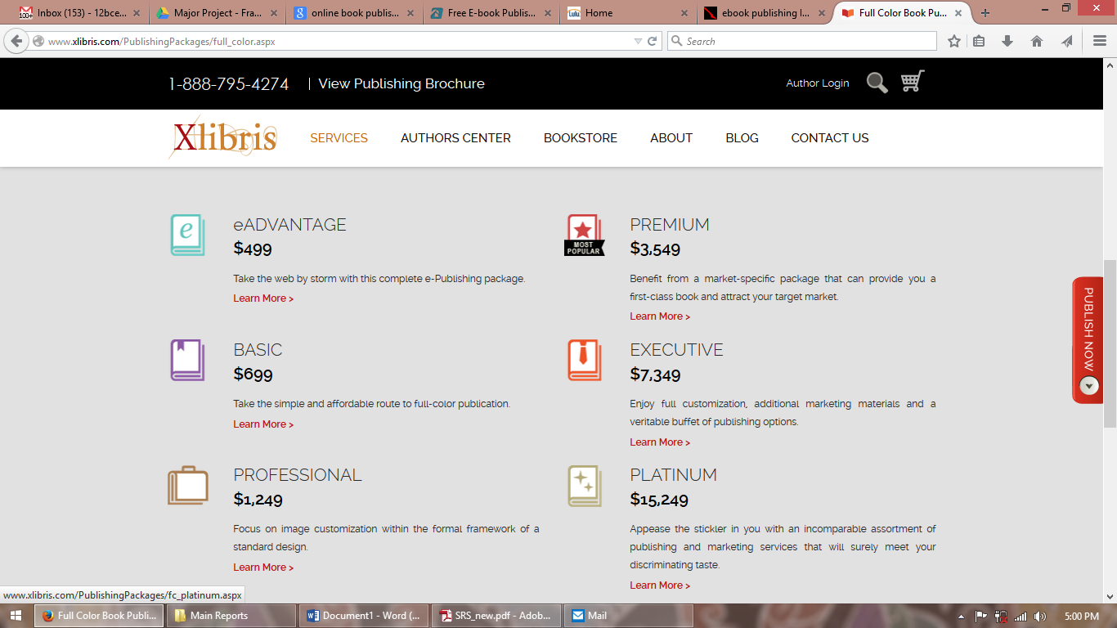

**Name: Xlibris**

|  |  |
| --- | --- |
| Application type | Dynamic(Php), database, responsive, Touch friendly |
| Content Platform | Custom |
| Dynamic Content | No |
| Lacuna | Site uses custom platform which is fine if content never leaves the site environment.  Dynamic content is loaded on the fly also provision to store user data.  The site provides the tools to create the content but these tools are only offline and they cannot create interactive content.  The subscription plan that this site provides are way too costly and requires significant investment on initial phases. |
| Our Solution | The content generated by our site will be in the standard open format that can be accessed on the wide variety of devices without any dependencies with our framework or tools.  Also this format will support that advanced interaction features making it more valuable and engaging.  Our set to technologies are very customizable and also flexible enough that let us create unlimited set of templates regardless of the technologies we use.  The sponsor mechanism will let us make revenue to publish the content without making a mess out of irritating online advertisement and will also greatly reduces the cost associated with the publishing and generation. |

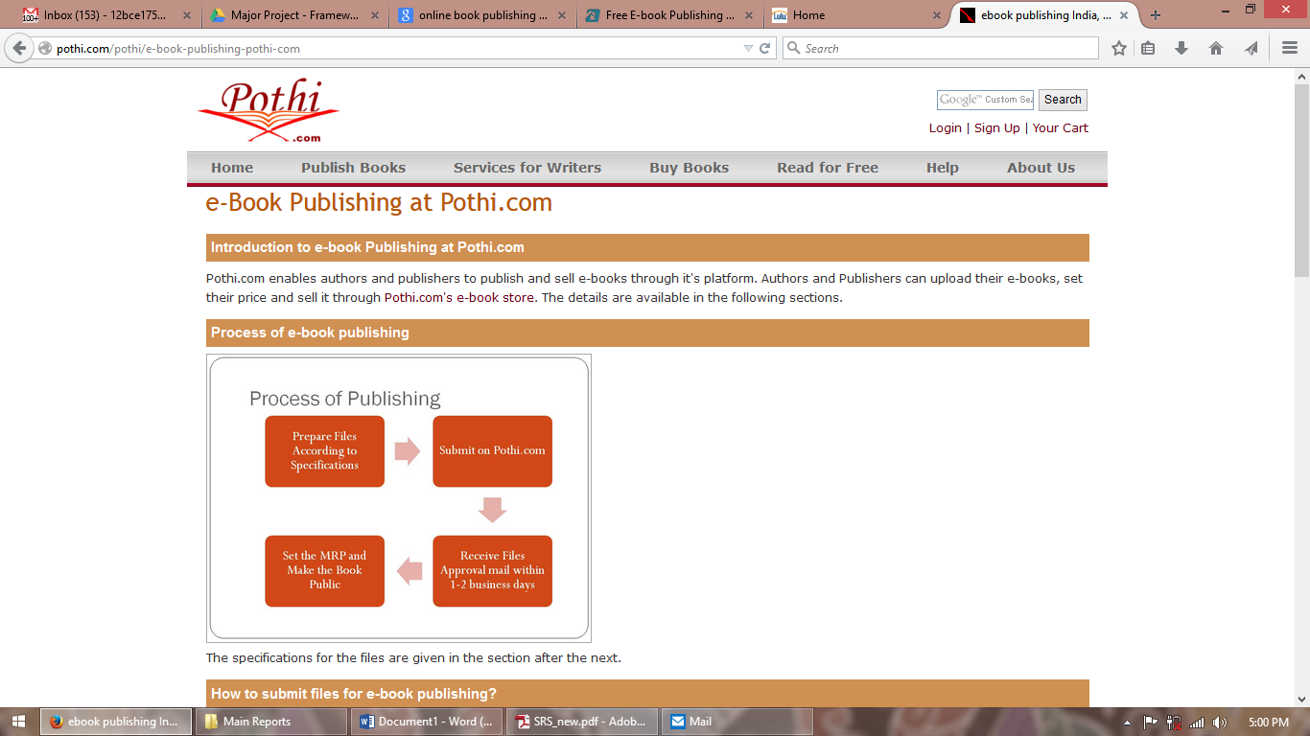

**Name: pothi**

|  |  |
| --- | --- |
| Application type | Dynamic(ASP.net), database, non-responsive, non-Touch friendly |
| Content Platform | PDF |
| Dynamic Content | No |
| Lacuna | Site use PDF as the content platform making it limited to the features that PDF can support.  Also the site is non-responsive and non-touch friendly making it difficult to use it on mobile and tablet devices.  Dynamic content is loaded on the fly also provision to store user data.  Site uses a very poor backend making everything manual from content submission to content approval and then publishing. |
| Our Solution | The content generated by our site will be in the standard open format that can be accessed on the wide variety of devices without any dependencies with our framework or tools.  Also this format will support that advanced interaction features making it more valuable and engaging.  Our automatic approver and reviewer workflows will make approval and review a breeze. |

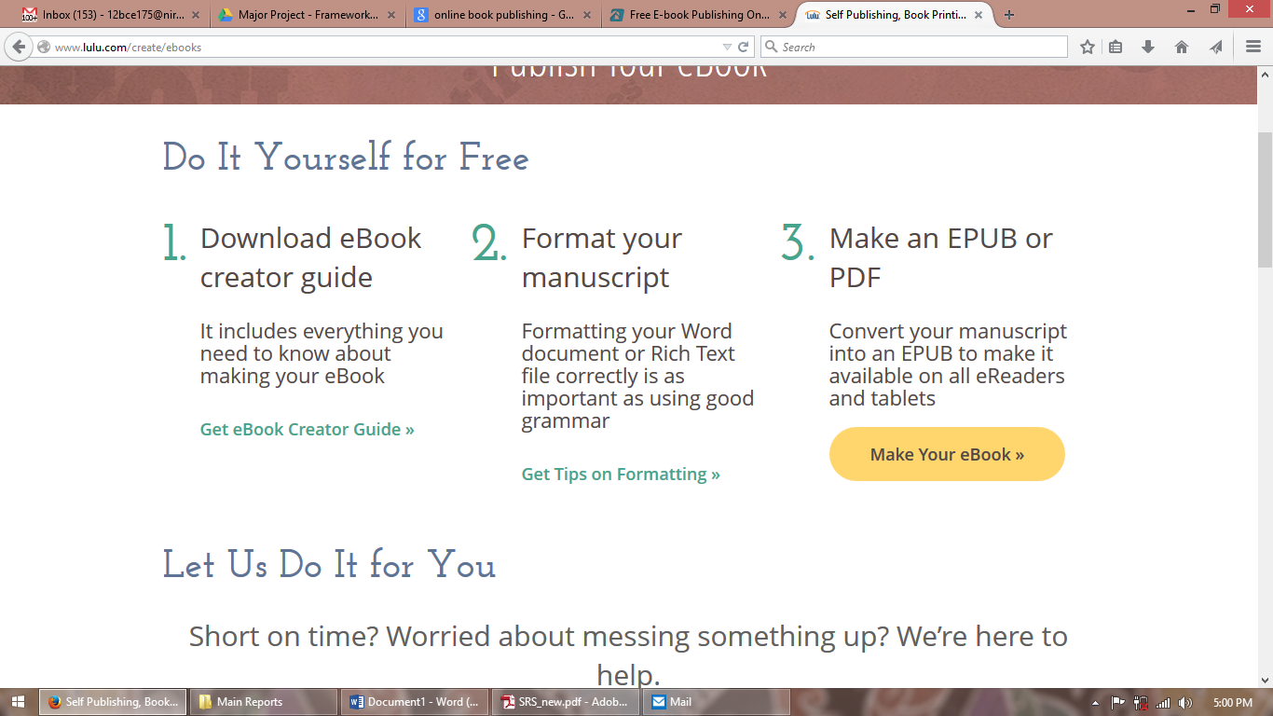

**Name: bookbaby**

|  |  |
| --- | --- |
| Application type | Dynamic(php), database, responsive, Touch friendly |
| Content Platform | PDF |
| Dynamic Content | No |
| Lacuna | Site use PDF as the content platform making it limited to the features that PDF can support.  Also the site is non-responsive and non-touch friendly making it difficult to use it on mobile and tablet devices.  Tools are available to create the content but these tools are strictly offline and can output only two file version, PDF and EPUB. |
| Our Solution | The content generated by our site will be in the standard open format that can be accessed on the wide variety of devices without any dependencies with our framework or tools.  Also this format will support that advanced interaction features making it more valuable and engaging.  All the tools that we create using this framework are always online and can be accessed from anywhere using any device. |

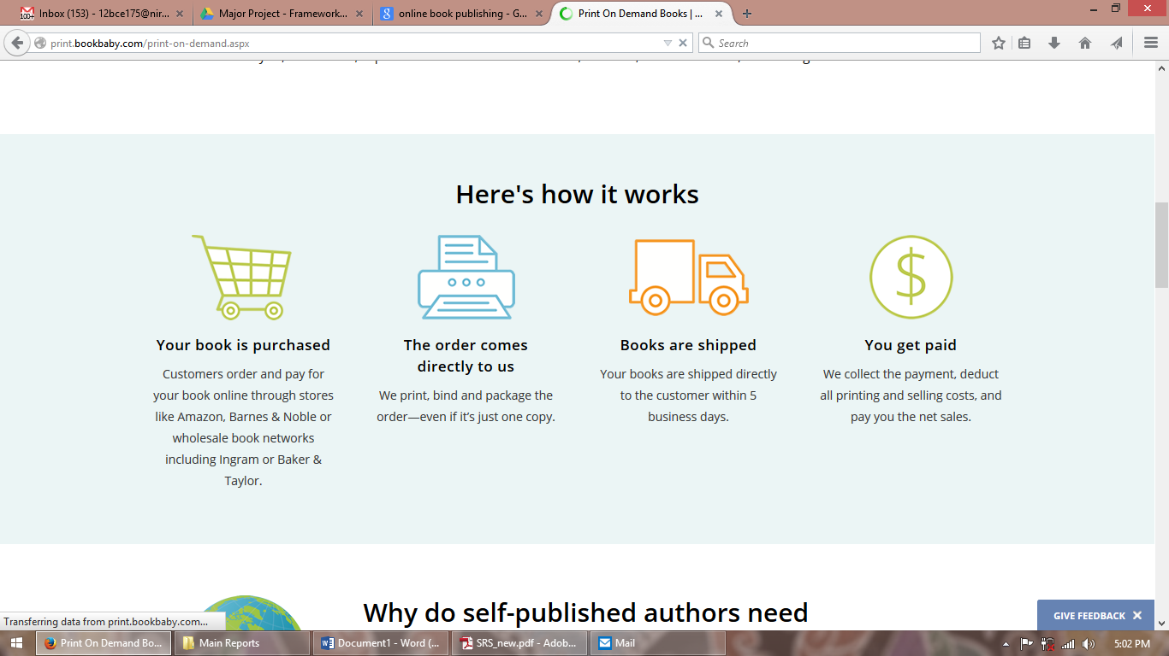

**Name: bookbaby**

|  |  |
| --- | --- |
| Application type | Dynamic(php), database, responsive, Touch friendly |
| Content Platform | PDF |
| Dynamic Content | No |
| Lacuna | Site use PDF as the content platform making it limited to the features that PDF can support.  Also the site is non-responsive and non-touch friendly making it difficult to use it on mobile and tablet devices.  Tools are available to create the content but these tools are strictly offline and can output only two file version, PDF and EPUB.  The site still generates revenue from printing the books, which day by day are becoming more costly to buy and produce. |
| Our Solution | The content generated by our site will be in the standard open format that can be accessed on the wide variety of devices without any dependencies with our framework or tools.  Also this format will support that advanced interaction features making it more valuable and engaging.  All the tools that we create using this framework are always online and can be accessed from anywhere using any device.  Our tools and technologies are web 2.0 technologies and will greatly emphasis on saving the environment and hence we will provide limited support to the printable content. |

**Chapter 3**

# System Design

## 

## 3.1 Product perspective

**Browser**

**Http Server (WAMP)**

**Web Service Client**

**MySQL**

**Cloud Data Storage**

**Web Service Engine**

**(Apache)**

**Content Generation Engine**

**Content Publishing Engine**

### 3.1.1 Software Interface

### 3.1.2 Client on Internet |

Web Browser, Operating System (any)

### 3.1.3 Web Server

WAMP, Operating System (Windows)

### 3.1.4 Data Base Server

MySQL, Operating System (windows)

### 3.1.5 Development End

RAD (PHP, HTML, XML, AJAX, JQuery), MYSQL, OS (Windows),WAMP (Web Server)

## 3.2 Hardware Interface

### 3.2.1 Minimum requirements

|  |  |  |  |
| --- | --- | --- | --- |
| **Client Side** | | | |
|  | Processor | Ram | Disk Space |
| **Internet explorer 8** | Intel Pentium III or AMD -  800 MHz | 128 MB | 100 MB |

|  |  |  |  |
| --- | --- | --- | --- |
| **Server Side** | | | |
|  | Processor | Ram | Disk Space |
| **RAD** | Intel Pentium III or AMD -  800 MHz | 1 GB | 3.5 GB |
| **MySQL** | Intel Pentium III or AMD -  800 MHz | 256 MB | 150 MB |

### 3.2.2 Recommended requirements

|  |  |  |  |
| --- | --- | --- | --- |
| **Client Side** | | | |
|  | Processor | Ram | Disk Space |
| **RAD** | All Intel or AMD - 1 GHZ | 256 MB | 100 MB |

|  |  |  |  |
| --- | --- | --- | --- |
| **Server Side** | | | |
|  | Processor | Ram | Disk Space |
| **Internet explorer 8** | All Intel or AMD - 2 GHZ | 2 GB | 3.5 GB |
| **MySQL** | All Intel or AMD - 2 GHZ | 512 MB | 500 MB |

## 3.3 Communication Interface

* Client (customer) on Internet will be using HTTP/HTTPS protocol.
* Client (system user) on Internet will be using HTTP/HTTPS protocol

## 3.4 Constraints

* GUI is only in English.
* Login and password is used for the identification of users.
* Only registered users will be authorized to use the services.
* Limited to HTTP/HTTPS.

## 3.5 Use Case Model Survey



### 3.5.1 Administrator

A super user with superior privileges that affects the whole system including the users of the system. It can manage users, generate reports and also sets the scope of the user’s actions using page management.

### 3.5.2 Approver

This user would approve/ reject the content published by publisher.

### 3.5.3 Reviewer

This user would review the decision taken by the approver for final release.

### 3.5.4 Sales Executive

This user would generate and associate valid subscription plan with the publisher content and would also assign the service agreement on using the published content.

### 3.5.5 Publisher

This user is responsible for generation of the content using the system tools and content templates. It would also manage the assets that published content would use. It would manage the sponsors and publishers associated with each generated content.

### 3.5.6 Manger

This user is responsible for managing the content types and templates that publisher would require and consume. This user is also responsible for managing the asset types that system supports.

## 3.6 Architecture Diagram

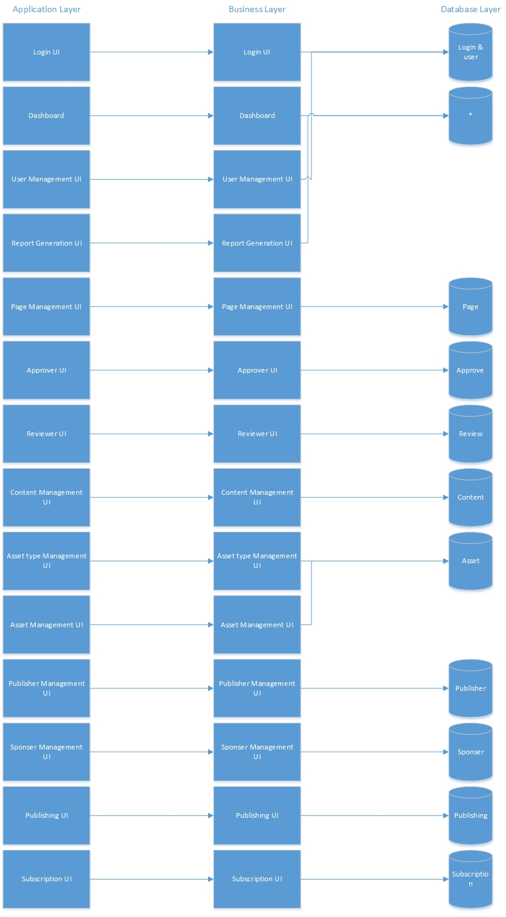

## 3.7 Database Design

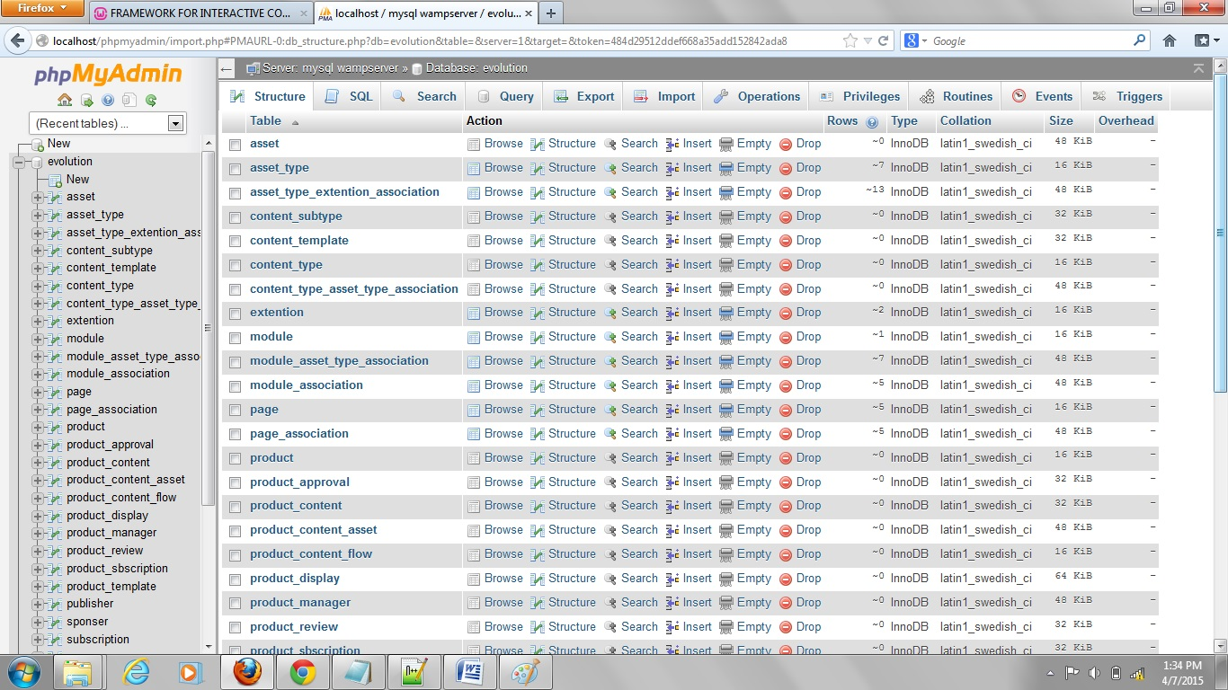

## 3.8 Specific Requirements

### 3.8.1 Use case reports

#### 3.8.1.1 Administrator



### 

#### 3.8.1.2 Approver



#### 3.8.1.3 Reviewer



### 

#### 3.8.1.4 Manager



### 

#### 3.8.1.5 Publisher



#### 3.8.1.6 Sales Executive



### 3.8.2 Activity Diagrams

#### 3.8.2.1 Generalized Object insertion diagram

## 

#### 3.8.2.2 Generalized Object editing diagram

## 

#### 3.8.2.3 Generalized Object Deleting diagram

## object deletion

#### 3.8.2.4 Generalized user login Diagram

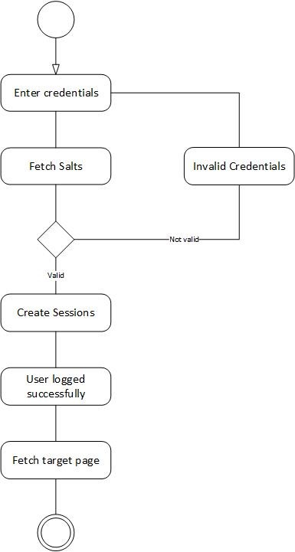

#### 3.8.2.5 Content publishing diagrampublish_content

#### 3.8.2.6 Content Approval diagramapprove

#### 3.8.2.7 Content Review diagram

### 

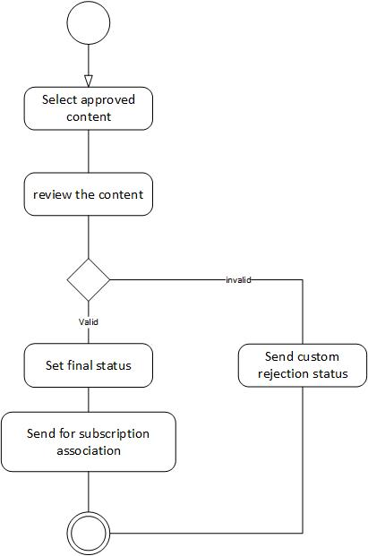

#### 3.8.2.8 Content push staging diagram

### salesExecutive

## 

### userLoginSequence3.8.3 Sequence Diagrams

#### 3.8.3.1 User login sequence diagram

#### 3.8.3.2 Add object sequence diagramaddObjectSequence

#### 

#### 3.8.3.3 Edit Object sequence diagram

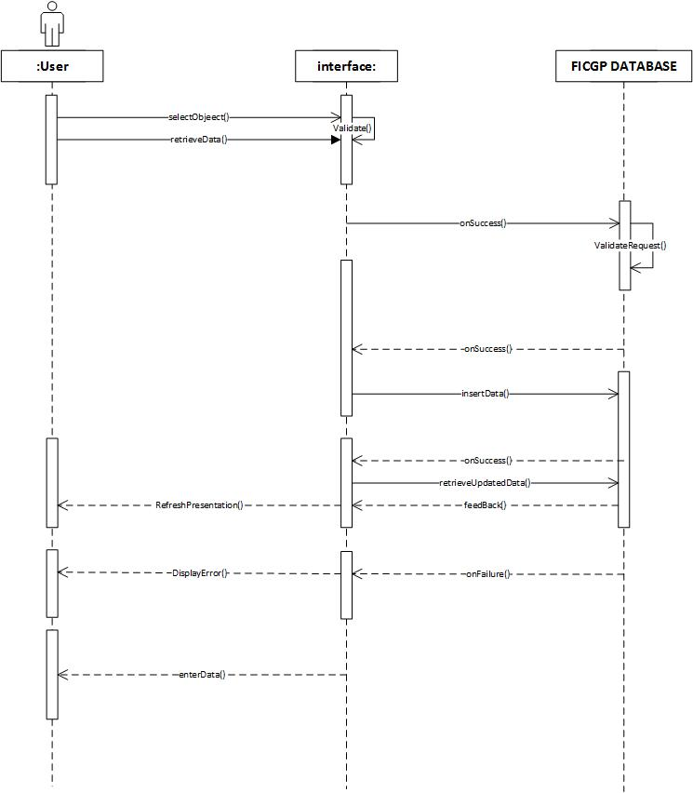

#### editObject3.8.3.4 Delete Object sequence diagram

#### 3.8.3.5 Publishing Sequence DiagrampublishingSequenceDiagram

### 3.8.4 Class Diagram

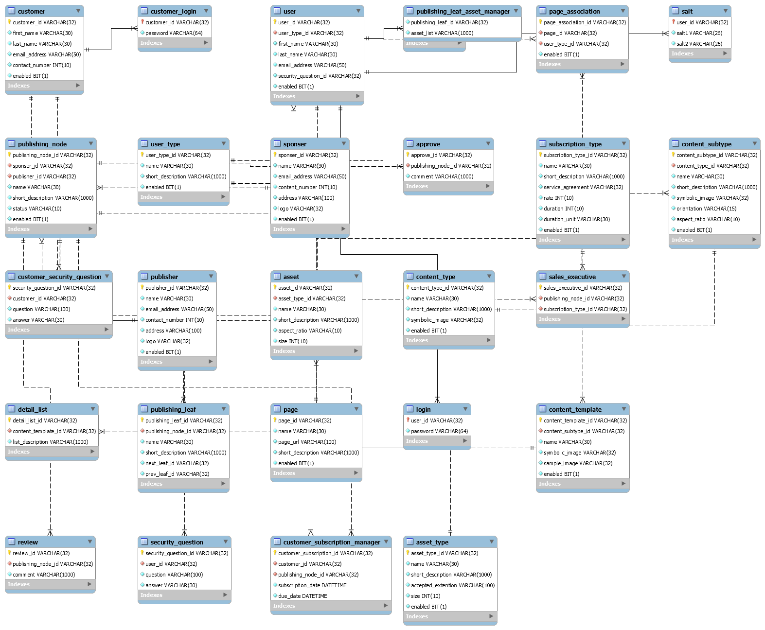

### 

### 3.8.5 CRC Index Cards

Approve

|  |  |
| --- | --- |
| **Class Name :** | **Approve** |
| Class Type : | Interaction |
| Class Characteristics : | Tangibility : Intangible  Sequential : Concurrent  Persistence : Temporary  Inclusiveness : Aggregate  Integrity : Guarded |
| Responsibility : | Collaborations : |
| Approve()  Publish() | Publishing Node |

Asset Type

|  |  |
| --- | --- |
| **Class Name :** | **Asset Type** |
| Class Type : | Domain |
| Class Characteristics : | Tangibility : Tangible  Sequential : Sequential  Persistence : Temporary  Inclusiveness : Stand Alone  Integrity : Guarded |
| Responsibility : | Collaborations : |
| Create()  Update()  Delete() | Asset  Content Type Asset Type Association  Module Asset Type Association |

Asset Type Extension Association

|  |  |
| --- | --- |
| **Class Name :** | **Asset Type** |
| Class Type : | Domain |
| Class Characteristics : | Tangibility : Tangible  Sequential : Sequential  Persistence : Temporary  Inclusiveness : Stand Alone  Integrity : Guarded |
| Responsibility : | Collaborations : |
| Create()  Update()  Delete() | Asset Type |

Asset

|  |  |
| --- | --- |
| **Class Name :** | **Asset** |
| Class Type : | Domain |
| Class Characteristics : | Tangibility : Tangible  Sequential : Sequential  Persistence : Temporary  Inclusiveness : Aggregate  Integrity : Guarded |
| Responsibility : | Collaborations : |
| Create()  Update()  Delete() | Asset Type  Product Content Asset |

Authorized

|  |  |
| --- | --- |
| **Class Name :** | **Asset Type** |
| Class Type : | Domain |
| Class Characteristics : | Tangibility : Tangible  Sequential : Sequential  Persistence : Temporary  Inclusiveness : Stand Alone  Integrity : Guarded |
| Responsibility : | Collaborations : |
| Create()  Update()  Delete() | Login |

Content Type

|  |  |
| --- | --- |
| **Class Name :** | **Content Type** |
| Class Type : | Domain |
| Class Characteristics : | Tangibility : Tangible  Sequential : Sequential  Persistence : Temporary  Inclusiveness : Stand Alone  Integrity : Guarded |
| Responsibility : | Collaborations : |
| Create()  Update()  Delete() | Content Subtype  Content Template  Content Type Asset Type Association  Product Manager |

Content Subtype

|  |  |
| --- | --- |
| **Class Name :** | **Content Subtype** |
| Class Type : | Domain |
| Class Characteristics : | Tangibility : Tangible  Sequential : Sequential  Persistence : Temporary  Inclusiveness : Aggregate  Integrity : Guarded |
| Responsibility : | Collaborations : |
| Create()  Update()  Delete() | Content Type  Product Manager |

Content Template

|  |  |
| --- | --- |
| **Class Name :** | **Content Template** |
| Class Type : | Domain |
| Class Characteristics : | Tangibility : Tangible  Sequential : Concurrent  Persistence : Permanent  Inclusiveness : Aggregate  Integrity : Guarded |
| Responsibility : | Collaborations : |
| Create()  Update()  Delete() | Content Type  Detail List  Content Template Hint  Product Template |

Content Template Hint

|  |  |
| --- | --- |
| **Class Name :** | **Asset Type** |
| Class Type : | Domain |
| Class Characteristics : | Tangibility : Tangible  Sequential : Sequential  Persistence : Temporary  Inclusiveness : Stand Alone  Integrity : Guarded |
| Responsibility : | Collaborations : |
| Create()  Update()  Delete() | Content Template |

Content Type Asset Type Association

|  |  |
| --- | --- |
| **Class Name :** | **Asset Type** |
| Class Type : | Domain |
| Class Characteristics : | Tangibility : Tangible  Sequential : Sequential  Persistence : Temporary  Inclusiveness : Stand Alone  Integrity : Guarded |
| Responsibility : | Collaborations : |
| Create()  Update()  Delete() | Asset Type  Content Type |

Detail List

|  |  |
| --- | --- |
| **Class Name :** | **Detail List** |
| Class Type : | Interaction |
| Class Characteristics : | Tangibility : Intangible  Sequential : Concurrent  Persistence : Temporary  Inclusiveness : Aggregate  Integrity : Guarded |
| Responsibility : | Collaborations : |
| Create()  Update()  Delete() | Content Template |

Content Manager

|  |  |
| --- | --- |
| **Class Name :** | **Content Manager** |
| Class Type : | Interaction |
| Class Characteristics : | Tangibility : Intangible  Sequential : Concurrent  Persistence : Temporary  Inclusiveness : Aggregate  Integrity : Guarded |
| Responsibility : | Collaborations : |
| Manage() | Content Type  Content Subtype |

Customer

|  |  |
| --- | --- |
| **Class Name :** | **Customer** |
| Class Type : | Domain |
| Class Characteristics : | Tangibility : Intangible  Sequential : Concurrent  Persistence : Temporary  Inclusiveness : Stand Alone  Integrity : Guarded |
| Responsibility : | Collaborations : |
| Login() |  |

Customer Login

|  |  |
| --- | --- |
| **Class Name :** | **Customer Login** |
| Class Type : | Interaction |
| Class Characteristics : | Tangibility : Intangible  Sequential : Concurrent  Persistence : Temporary  Inclusiveness : Aggregate  Integrity : Guarded |
| Responsibility : | Collaborations : |
| Login() | Customer Security Question  Customer Subscription Manager |

Customer Security Question

|  |  |
| --- | --- |
| **Class Name :** | **Customer Security Question** |
| Class Type : | Interaction |
| Class Characteristics : | Tangibility : Intangible  Sequential : Concurrent  Persistence : Temporary  Inclusiveness : Aggregate  Integrity : Guarded |
| Responsibility : | Collaborations : |
| Insert() | Customer Login |

Customer Subscription Manager

|  |  |
| --- | --- |
| **Class Name :** | **Customer Subscription Manager** |
| Class Type : | Interaction |
| Class Characteristics : | Tangibility : Intangible  Sequential : Concurrent  Persistence : Temporary  Inclusiveness : Aggregate  Integrity : Guarded |
| Responsibility : | Collaborations : |
| Manage() | Customer Login  Publishing Node |

Extension

|  |  |
| --- | --- |
| **Class Name :** | **Asset Type** |
| Class Type : | Domain |
| Class Characteristics : | Tangibility : Tangible  Sequential : Sequential  Persistence : Temporary  Inclusiveness : Stand Alone  Integrity : Guarded |
| Responsibility : | Collaborations : |
| Create()  Update()  Delete() |  |

Module

|  |  |
| --- | --- |
| **Class Name :** | **Asset Type** |
| Class Type : | Domain |
| Class Characteristics : | Tangibility : Tangible  Sequential : Sequential  Persistence : Temporary  Inclusiveness : Stand Alone  Integrity : Guarded |
| Responsibility : | Collaborations : |
| Create()  Update()  Delete() | Module Asset Type Association  Module Association |

Module Asset Type Association

|  |  |
| --- | --- |
| **Class Name :** | **Asset Type** |
| Class Type : | Domain |
| Class Characteristics : | Tangibility : Tangible  Sequential : Sequential  Persistence : Temporary  Inclusiveness : Stand Alone  Integrity : Guarded |
| Responsibility : | Collaborations : |
| Create()  Update()  Delete() | Module  Asset Type |

Module Association

|  |  |
| --- | --- |
| **Class Name :** | **Asset Type** |
| Class Type : | Domain |
| Class Characteristics : | Tangibility : Tangible  Sequential : Sequential  Persistence : Temporary  Inclusiveness : Stand Alone  Integrity : Guarded |
| Responsibility : | Collaborations : |
| Create()  Update()  Delete() | Page  Module |

Page

|  |  |
| --- | --- |
| **Class Name :** | **Asset Type** |
| Class Type : | Domain |
| Class Characteristics : | Tangibility : Tangible  Sequential : Sequential  Persistence : Temporary  Inclusiveness : Stand Alone  Integrity : Guarded |
| Responsibility : | Collaborations : |
| Create()  Update()  Delete() | Module Association  Page Association |

Page Association

|  |  |
| --- | --- |
| **Class Name :** | **Asset Type** |
| Class Type : | Domain |
| Class Characteristics : | Tangibility : Tangible  Sequential : Sequential  Persistence : Temporary  Inclusiveness : Stand Alone  Integrity : Guarded |
| Responsibility : | Collaborations : |
| Create()  Update()  Delete() | Page  User Type |

Product

|  |  |
| --- | --- |
| **Class Name :** | **Asset Type** |
| Class Type : | Domain |
| Class Characteristics : | Tangibility : Tangible  Sequential : Sequential  Persistence : Temporary  Inclusiveness : Stand Alone  Integrity : Guarded |
| Responsibility : | Collaborations : |
| Create()  Update()  Delete() | Product Approval  Product Content  Product Display  Product Manager  Product Review |

Product Approval

|  |  |
| --- | --- |
| **Class Name :** | **Asset Type** |
| Class Type : | Domain |
| Class Characteristics : | Tangibility : Tangible  Sequential : Sequential  Persistence : Temporary  Inclusiveness : Stand Alone  Integrity : Guarded |
| Responsibility : | Collaborations : |
| Create()  Update()  Delete() | Product |

Product Content

|  |  |
| --- | --- |
| **Class Name :** | **Asset Type** |
| Class Type : | Domain |
| Class Characteristics : | Tangibility : Tangible  Sequential : Sequential  Persistence : Temporary  Inclusiveness : Stand Alone  Integrity : Guarded |
| Responsibility : | Collaborations : |
| Create()  Update()  Delete() | Product  Product Content Flow  Product Template  Product Content Asset |

Product Content Asset

|  |  |
| --- | --- |
| **Class Name :** | **Asset Type** |
| Class Type : | Domain |
| Class Characteristics : | Tangibility : Tangible  Sequential : Sequential  Persistence : Temporary  Inclusiveness : Stand Alone  Integrity : Guarded |
| Responsibility : | Collaborations : |
| Create()  Update()  Delete() | Asset  Product Content |

Product Content Flow

|  |  |
| --- | --- |
| **Class Name :** | **Asset Type** |
| Class Type : | Domain |
| Class Characteristics : | Tangibility : Tangible  Sequential : Sequential  Persistence : Temporary  Inclusiveness : Stand Alone  Integrity : Guarded |
| Responsibility : | Collaborations : |
| Create()  Update()  Delete() | Product Content |

Product Display

|  |  |
| --- | --- |
| **Class Name :** | **Asset Type** |
| Class Type : | Domain |
| Class Characteristics : | Tangibility : Tangible  Sequential : Sequential  Persistence : Temporary  Inclusiveness : Stand Alone  Integrity : Guarded |
| Responsibility : | Collaborations : |
| Create()  Update()  Delete() | Product  Sponsor  Publisher  Product Subscription |

Product Template

|  |  |
| --- | --- |
| **Class Name :** | **Asset Type** |
| Class Type : | Domain |
| Class Characteristics : | Tangibility : Tangible  Sequential : Sequential  Persistence : Temporary  Inclusiveness : Stand Alone  Integrity : Guarded |
| Responsibility : | Collaborations : |
| Create()  Update()  Delete() | Product Content  Content Template |

Product Manager

|  |  |
| --- | --- |
| **Class Name :** | **Asset Type** |
| Class Type : | Domain |
| Class Characteristics : | Tangibility : Tangible  Sequential : Sequential  Persistence : Temporary  Inclusiveness : Stand Alone  Integrity : Guarded |
| Responsibility : | Collaborations : |
| Create()  Update()  Delete() | Product  Content Type  Content Subtype |

Product Review

|  |  |
| --- | --- |
| **Class Name :** | **Asset Type** |
| Class Type : | Domain |
| Class Characteristics : | Tangibility : Tangible  Sequential : Sequential  Persistence : Temporary  Inclusiveness : Stand Alone  Integrity : Guarded |
| Responsibility : | Collaborations : |
| Create()  Update()  Delete() | Product |

Product Subscription

|  |  |
| --- | --- |
| **Class Name :** | **Asset Type** |
| Class Type : | Domain |
| Class Characteristics : | Tangibility : Tangible  Sequential : Sequential  Persistence : Temporary  Inclusiveness : Stand Alone  Integrity : Guarded |
| Responsibility : | Collaborations : |
| Create()  Update()  Delete() | Product Display  Subscription |

Publisher

|  |  |
| --- | --- |
| **Class Name :** | **Publisher** |
| Class Type : | Interaction |
| Class Characteristics : | Tangibility : Intangible  Sequential : Concurrent  Persistence : Temporary  Inclusiveness : Aggregate  Integrity : Guarded |
| Responsibility : | Collaborations : |
| Create()  Update()  Delete() | Publishing Node  Product Display |

Publishing Node

|  |  |
| --- | --- |
| **Class Name :** | **Publishing Node** |
| Class Type : | Domain |
| Class Characteristics : | Tangibility : Intangible  Sequential : Concurrent  Persistence : Temporary  Inclusiveness : Aggregate  Integrity : Guarded |
| Responsibility : | Collaborations : |
| Create()  Update()  Delete() | Approve  Customer Subscription Manager  Publishing Leaf  Sponsor  Publisher  Review  Sales Executive |

Publishing Leaf

|  |  |
| --- | --- |
| **Class Name :** | **Publishing Leaf** |
| Class Type : | Interaction |
| Class Characteristics : | Tangibility : Intangible  Sequential : Concurrent  Persistence : Temporary  Inclusiveness : Aggregate  Integrity : Guarded |
| Responsibility : | Collaborations : |
| Create()  Update()  Delete() | Publishing Node |

Publishing Leaf Asset Manager

|  |  |
| --- | --- |
| **Class Name :** | **Publishing Leaf Asset Manager** |
| Class Type : | Interaction |
| Class Characteristics : | Tangibility : Intangible  Sequential : Concurrent  Persistence : Temporary  Inclusiveness : Aggregate  Integrity : Guarded |
| Responsibility : | Collaborations : |
| Manage() |  |

Publishing Leaf Manager

|  |  |
| --- | --- |
| **Class Name :** | **Publishing Leaf Manager** |
| Class Type : | Interaction |
| Class Characteristics : | Tangibility : Intangible  Sequential : Concurrent  Persistence : Temporary  Inclusiveness : Aggregate  Integrity : Guarded |
| Responsibility : | Collaborations : |
| Manage() | Content Type  Content Subtype  Content Template |

Salt

|  |  |
| --- | --- |
| **Class Name :** | **Asset Type** |
| Class Type : | Domain |
| Class Characteristics : | Tangibility : Tangible  Sequential : Sequential  Persistence : Temporary  Inclusiveness : Stand Alone  Integrity : Guarded |
| Responsibility : | Collaborations : |
| Create()  Update()  Delete() | User |

Review

|  |  |
| --- | --- |
| **Class Name :** | **Review** |
| Class Type : | Interaction |
| Class Characteristics : | Tangibility : Intangible  Sequential : Concurrent  Persistence : Temporary  Inclusiveness : Aggregate  Integrity : Guarded |
| Responsibility : | Collaborations : |
| Create()  Update()  Delete() | Publishing Node |

Subscription Type

|  |  |
| --- | --- |
| **Class Name :** | **Subscription Type** |
| Class Type : | Domain |
| Class Characteristics : | Tangibility : Intangible  Sequential : Concurrent  Persistence : Temporary  Inclusiveness : Stand Alone  Integrity : Guarded |
| Responsibility : | Collaborations : |
| Create()  Update()  Delete() | Sales Executive |

Sales Executive

|  |  |
| --- | --- |
| **Class Name :** | **Sales Executive** |
| Class Type : | Interaction |
| Class Characteristics : | Tangibility : Intangible  Sequential : Concurrent  Persistence : Temporary  Inclusiveness : Aggregate  Integrity : Guarded |
| Responsibility : | Collaborations : |
| Create()  Update()  Delete() | Publishing Node  Subscription Type |

Sponsor

|  |  |
| --- | --- |
| **Class Name :** | **Sponsor** |
| Class Type : | Domain |
| Class Characteristics : | Tangibility : Intangible  Sequential : Concurrent  Persistence : Temporary  Inclusiveness : Stand Alone  Integrity : Guarded |
| Responsibility : | Collaborations : |
| Create()  Update()  Delete() | Publishing Node  Product Display |

Users Type

|  |  |
| --- | --- |
| **Class Name :** | **Users Type** |
| Class Type : | Domain |
| Class Characteristics : | Tangibility : Intangible  Sequential : Concurrent  Persistence : Temporary  Inclusiveness : Stand Alone  Integrity : Guarded |
| Responsibility : | Collaborations : |
| Create()  Update()  Delete() | User  Page Association |

User

|  |  |
| --- | --- |
| **Class Name :** | **User** |
| Class Type : | Interaction |
| Class Characteristics : | Tangibility : Intangible  Sequential : Concurrent  Persistence : Temporary  Inclusiveness : Aggregate  Integrity : Guarded |
| Responsibility : | Collaborations : |
| Create()  Update()  Delete() | Users Type  Security Question  Salt |

Login

|  |  |
| --- | --- |
| **Class Name :** | **Login** |
| Class Type : | Interaction |
| Class Characteristics : | Tangibility : Intangible  Sequential : Concurrent  Persistence : Temporary  Inclusiveness : Aggregate  Integrity : Guarded |
| Responsibility : | Collaborations : |
| Login() | Authorized |

Security Question

|  |  |
| --- | --- |
| **Class Name :** | **Security Question** |
| Class Type : | Interaction |
| Class Characteristics : | Tangibility : Intangible  Sequential : Concurrent  Persistence : Temporary  Inclusiveness : Aggregate  Integrity : Guarded |
| Responsibility : | Collaborations : |
| Insert() | User |

Subscription

|  |  |
| --- | --- |
| **Class Name :** | **Asset Type** |
| Class Type : | Domain |
| Class Characteristics : | Tangibility : Tangible  Sequential : Sequential  Persistence : Temporary  Inclusiveness : Stand Alone  Integrity : Guarded |
| Responsibility : | Collaborations : |
| Create()  Update()  Delete() | Product Subscription |

**Chapter 4**

# Implementation

## 4.1 Login

### 4.1.1 Login Authentication Page

Login Authentication Page is Home page of the framework. It is responsible for authentication of users. The users can authenticate by using either email address or username. There is secured password defined by user. The main login authentication page will be display as following below.

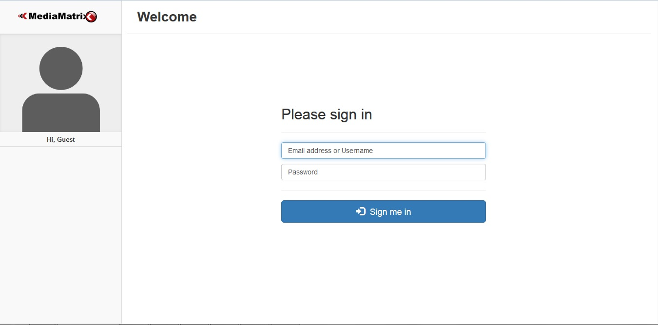

Figure 4.1.1

### 4.1.2 Login Authentication Process

Login authentication process requires either email address or user name, and password which is defined by user in order to sign into the portal. The login authentication process will be display as following below.

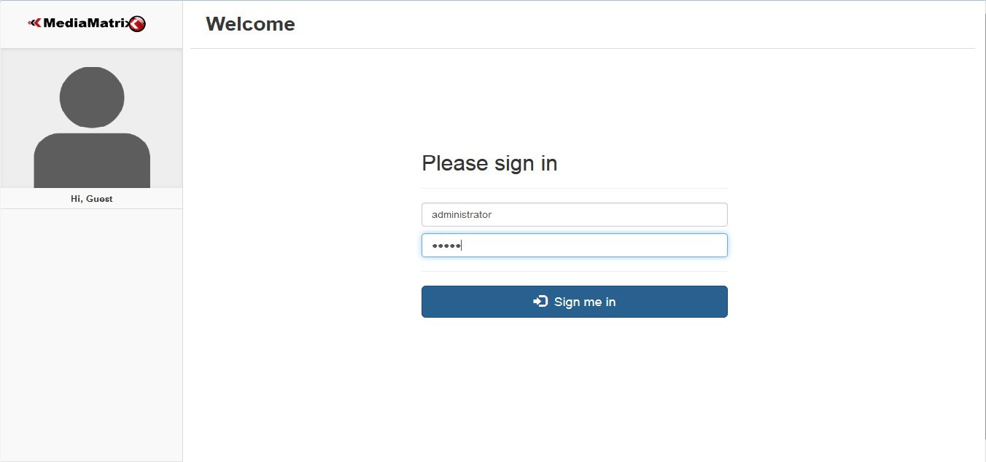

Figure 4.1.2

## 4.2 Database

The database is designed in MySQL using PHPmyAdmin. The database will be display as following below.



Figure 4.2

## 4.3 Implementation

### 4.3.1 Change Password

Any type of user can change their password using this facility. The change password form is provided with certain form filling guidelines which helps in validation. By clicking on change password will update the content in database.

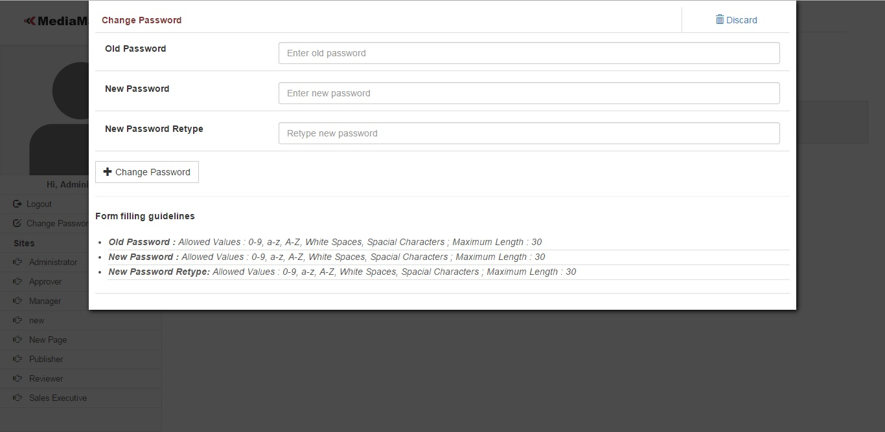

Figure 4.3.1

### 4.3.2 User Type Management

Main Page

This feature is managing user types. As per shown in below image there are two types of users administrator and publisher are involved in system.

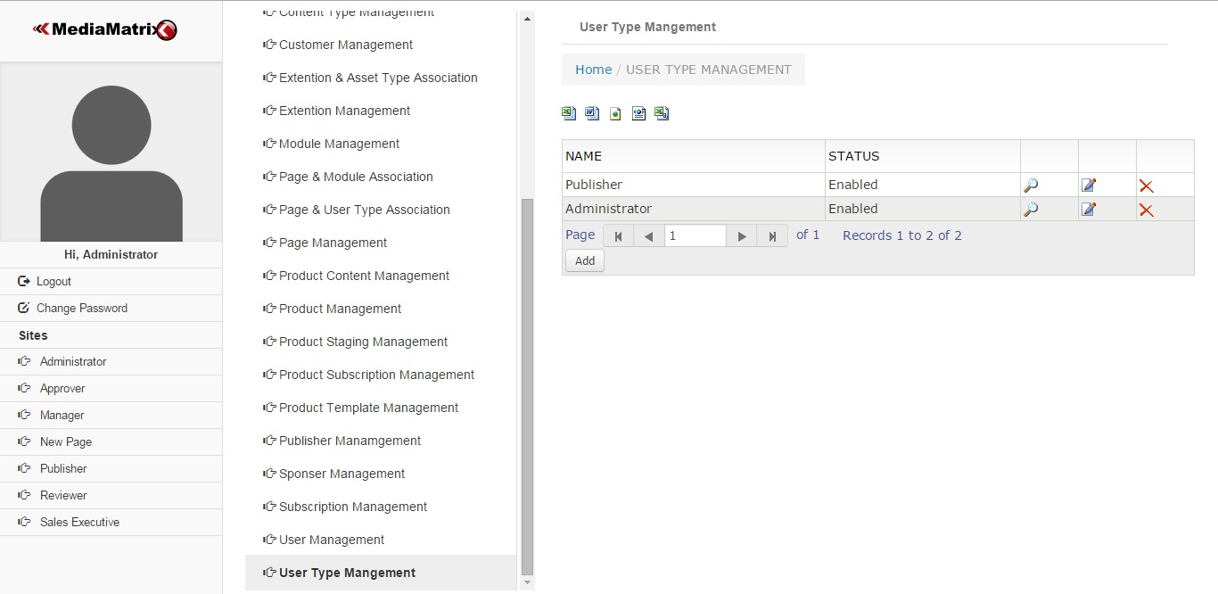

Figure 4.3.2.1

Add User Type

New user type can be added by using add user type form as shown below. In order to add new user type requires adding details about name and description about user type and the status whether it would be enabled or disabled.

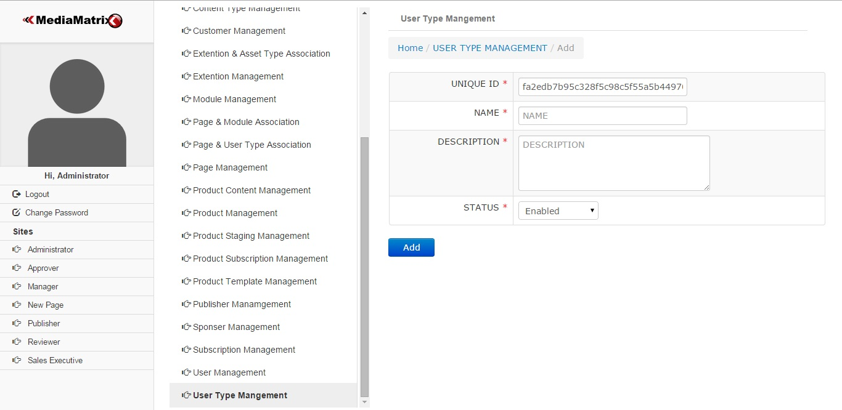

Figure 4.3.2.2

View User Type

User type can be viewed by using view feature as shown in below figure. View user type will display the details of user type that are name, description, date of creation and updating along with status.

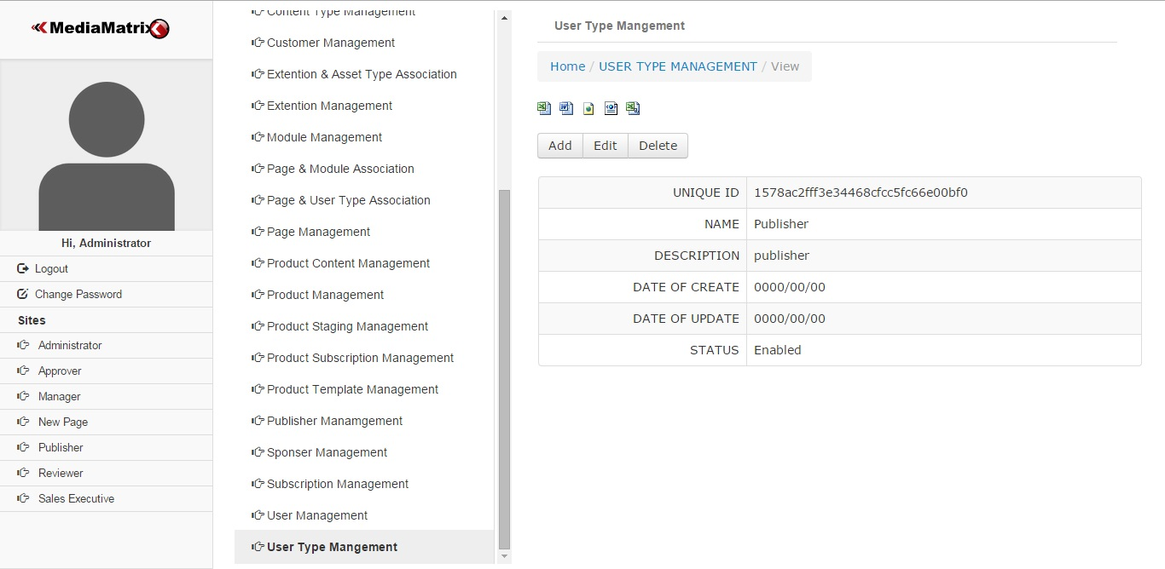

Figure 4.3.2.3

Edit User Type

Edit user type is used to edit the existing details of user type as shown in below figure.

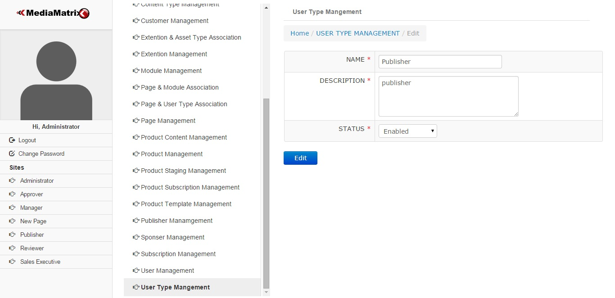

Figure 4.3.2.4

Delete User Type

Delete user type is used to delete user type as shown in below figure.

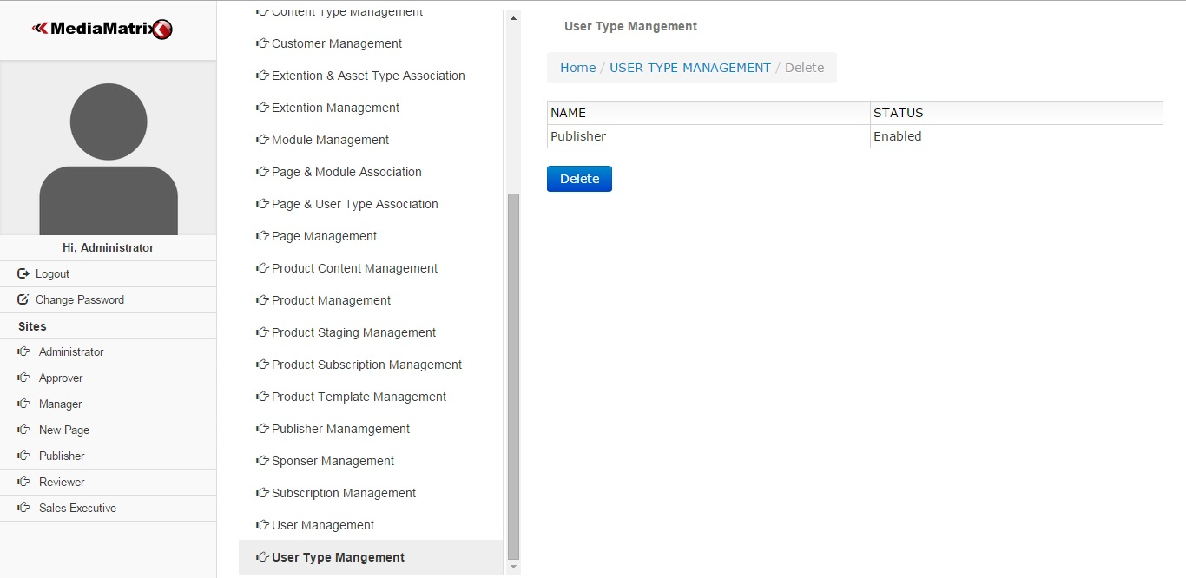

Figure 4.3.2.5

## 4.3.3 User Management

Main

User Management is responsible for managing users. It manages details about users such as user type, email address, name and status as shown in below figure.

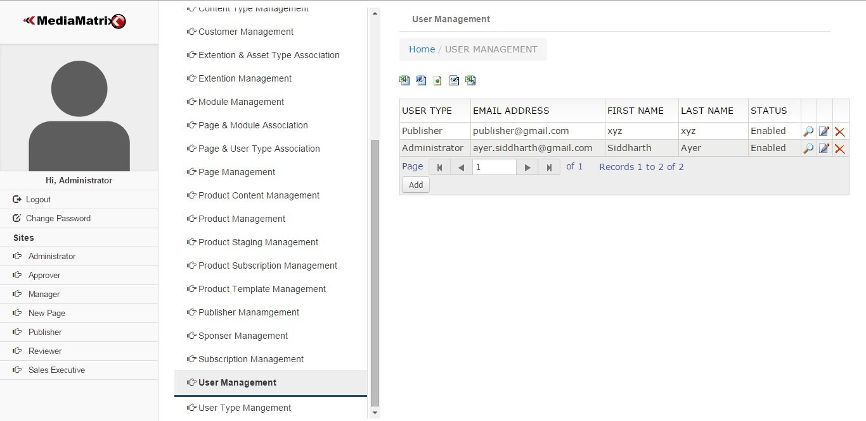

Figure 4.3.3.1

Add User Management

User can be adding by using below form.

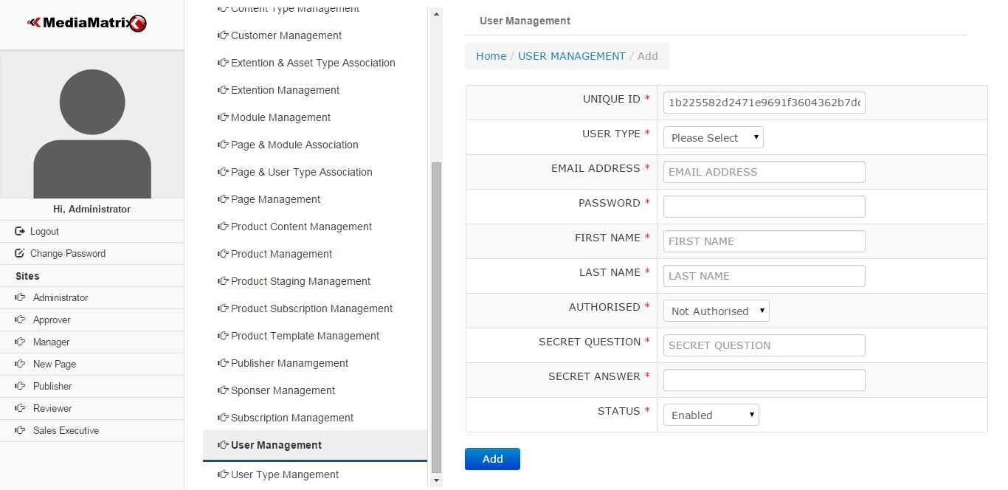

Figure 4.3.3.2

View User Management

User can be view through view facility as shown in below figure.

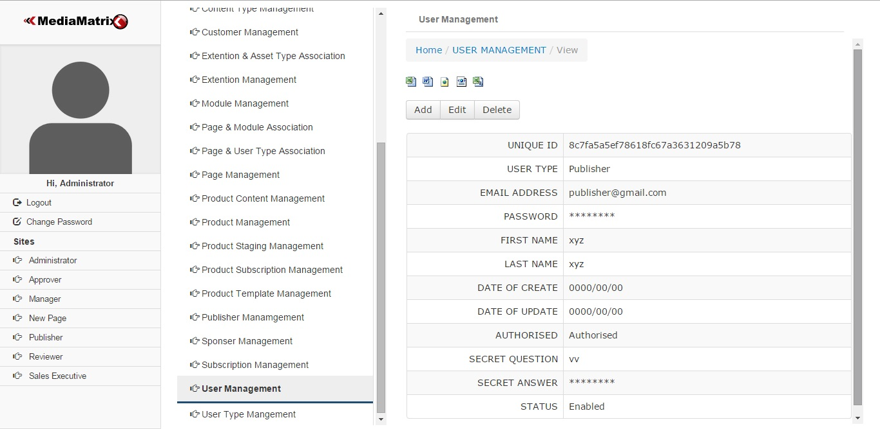

Figure 4.3.3.3

Edit User Management

User details can be edit by using edit form as shown below.

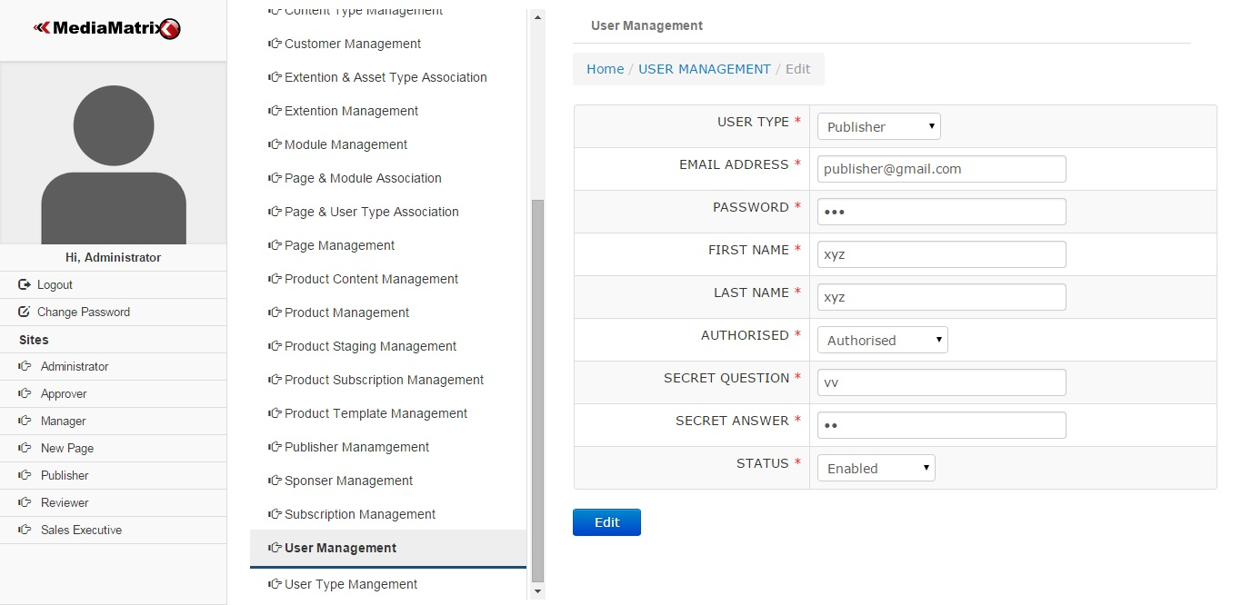

Figure 4.3.3.4

## 4.3.4 Page Management

Main

Page Management is used for managing page name, URL and status details as shown in below figure.

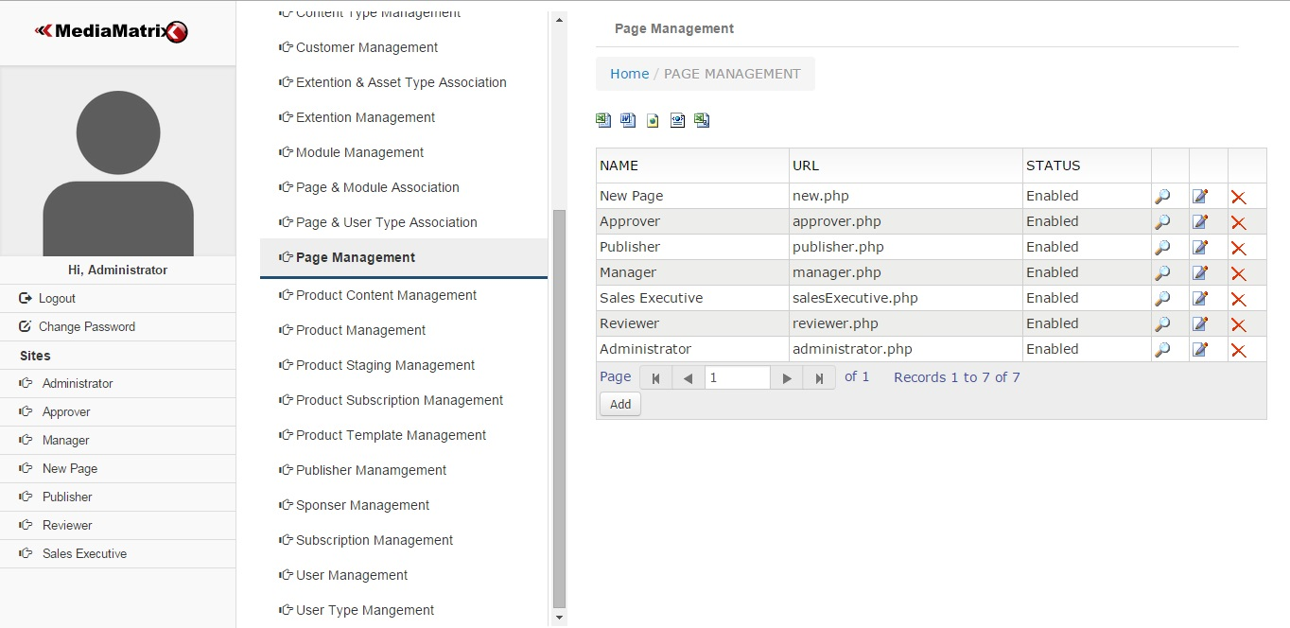

Figure 4.3.4.1

Add Page Management

Page can be added through add page management. This requires details of name, description, URL and status for page as shown in below figure.

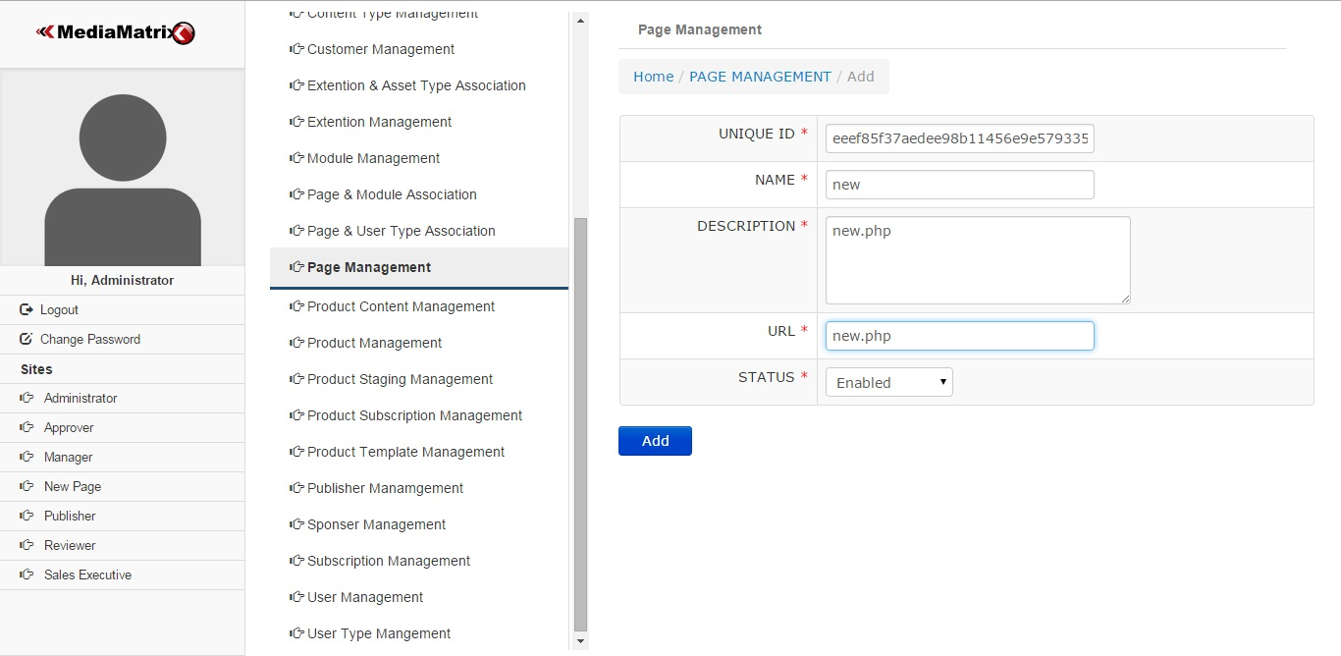

Figure 4.3.4.2

As shown in figure 4.3.4.3 below shows newly added page named new.

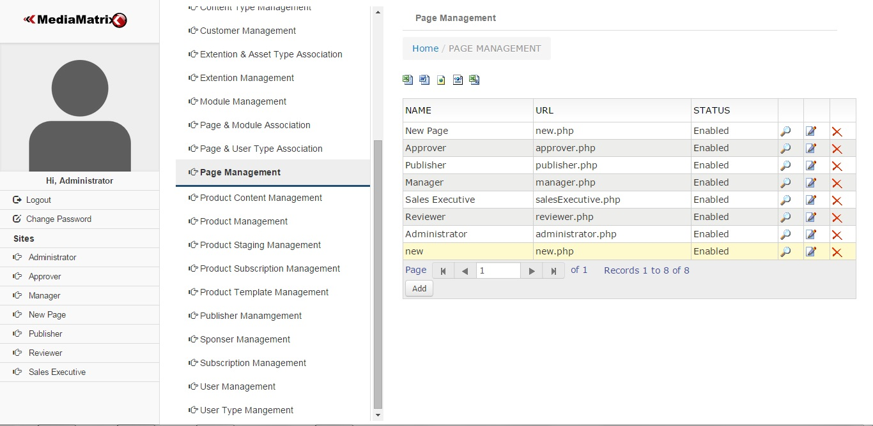

Figure 4.3.4.3

After refreshing site newly created page named new will be display in left side of the screen as shown in below figure.

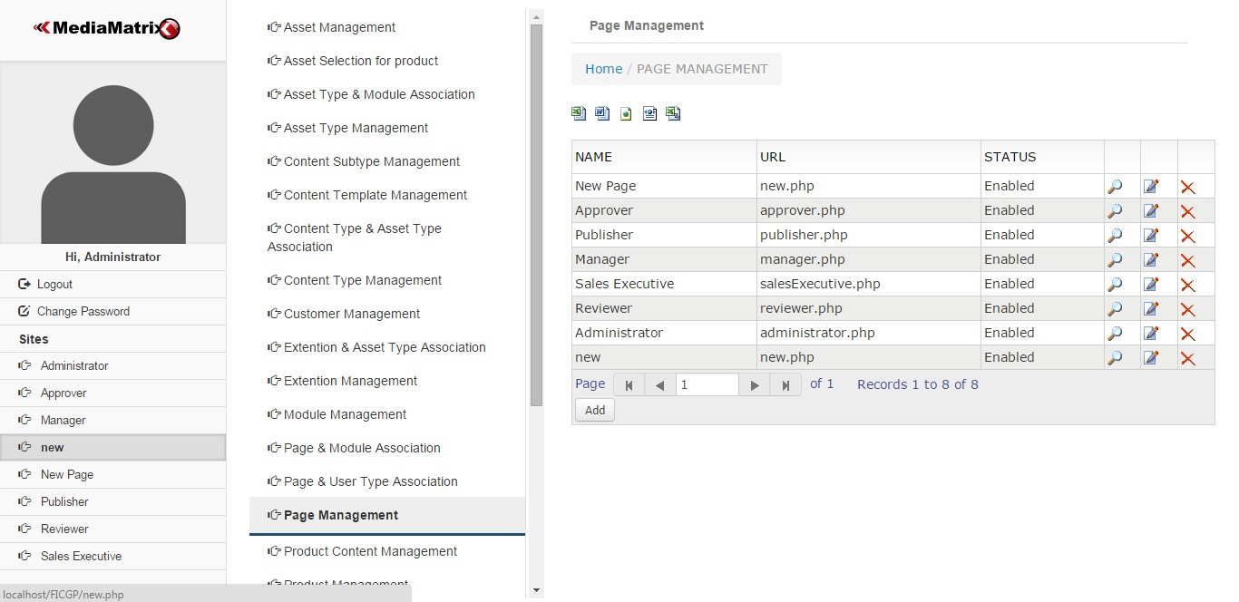

Figure 4.3.4.4

View Page Management

Page can be viewed by using view page management.

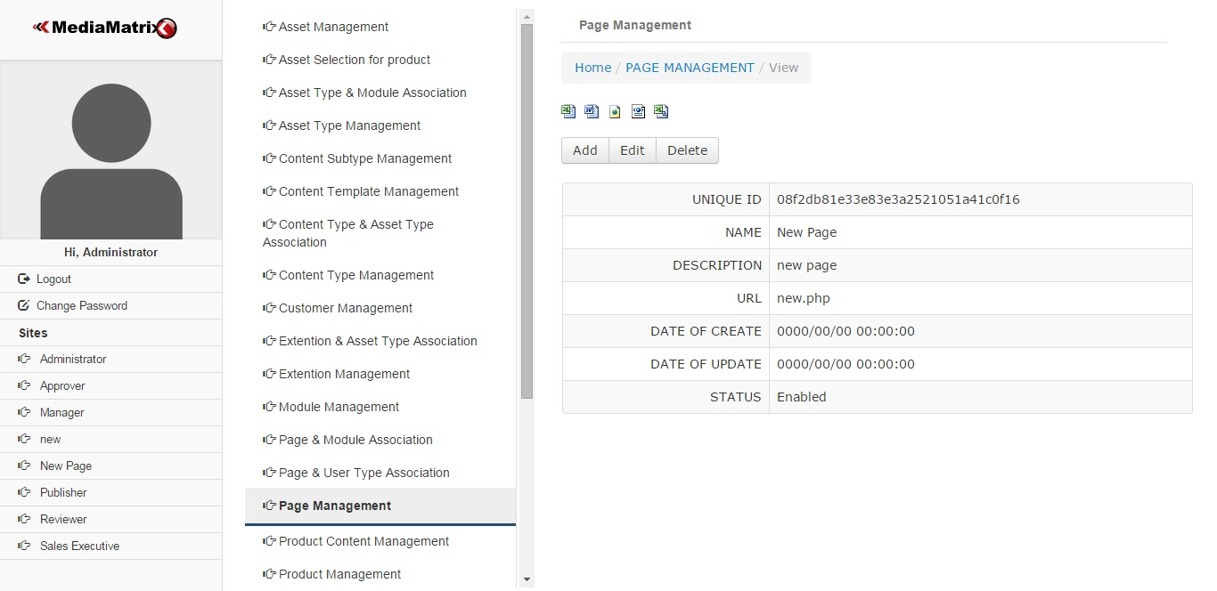

Figure 4.3.4.5

## 4.3.5 Page and User Type Association

Main Page

Page and user type association is an important feature. It is used to control accessing dashboard. Administrator can access dashboard of all user types but users should not have access to admin dashboard such kind of relationship can be set by using page and user type association management.

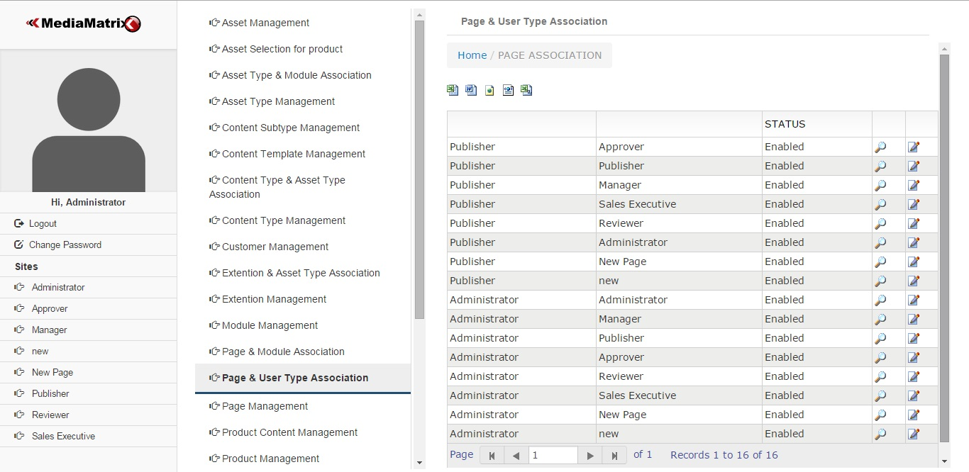

Figure 4.3.5.1

View Page and User Type Association

Page and User type association can be viewed as shown in below figure.

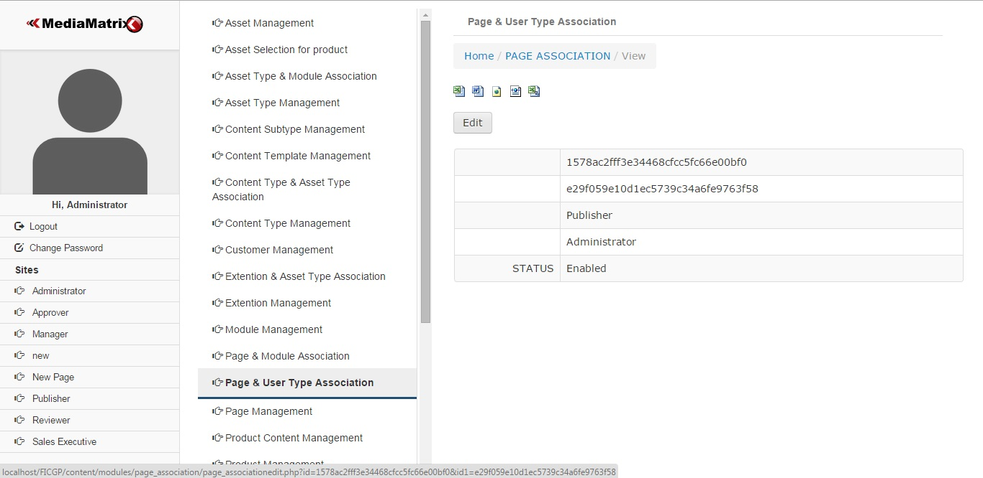

Figure 4.3.5.2

Edit Page and User Type Association

Edit page and user type association is used to control enabled and disabled features in order to provide restriction for accessing dashboards.

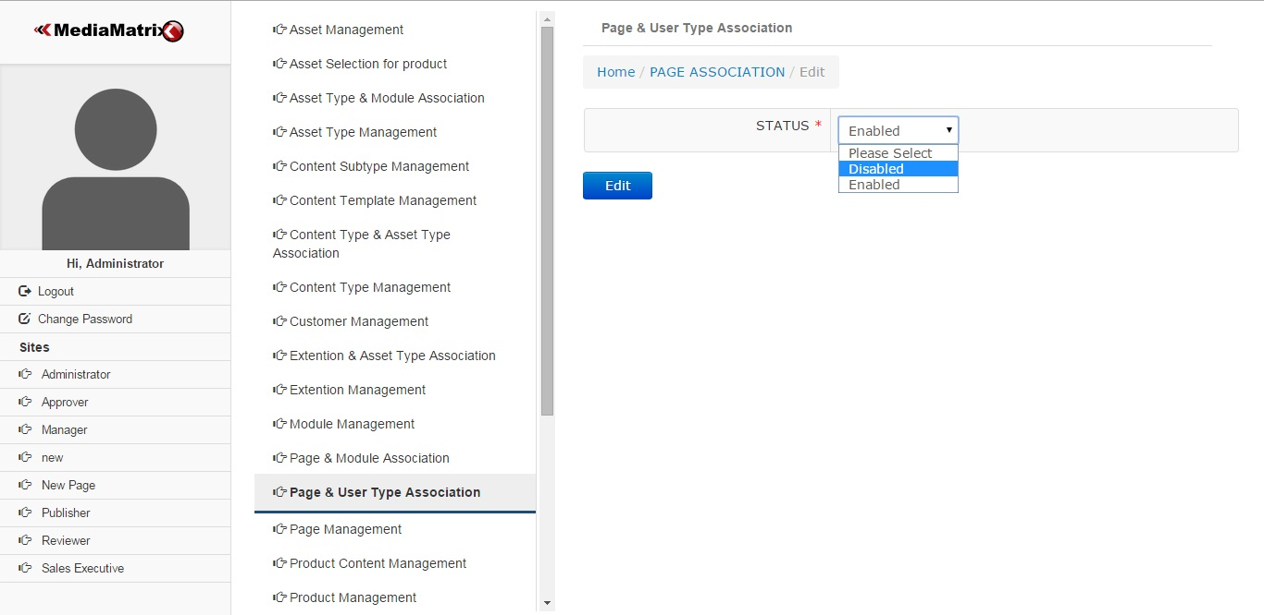

Figure 4.3.5.3

Enabled / Disabled

After performing disabled edit setting to publisher for accessing admin dashboard shown in below figure.

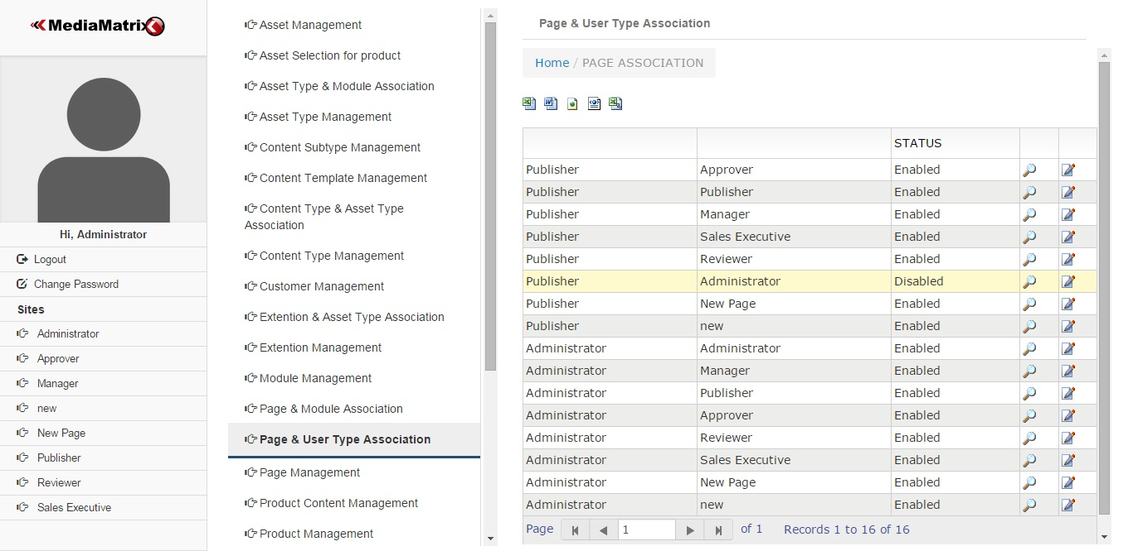

Figure 4.3.5.6

## 4.3.6 Module Management

Main

The middle column is said to be modules for site. Module management can be done by using this feature as shown in below figure.

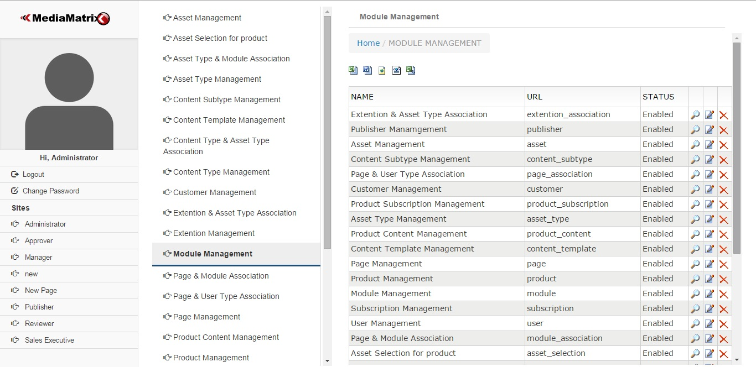

Figure 4.3.6.1

Add Module

Add module is used to add new module in site. This requires details such as name, description, URL and status to be entered as shown in below figure.

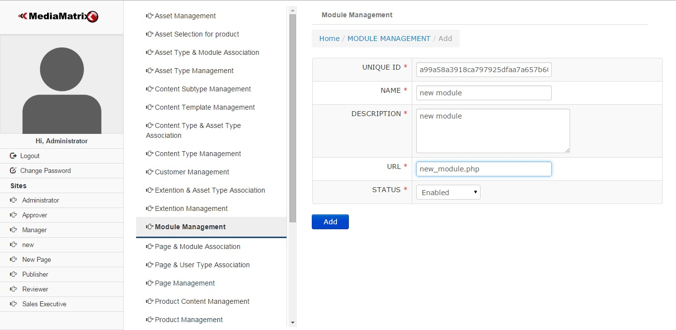

Figure 4.3.6.2

Display New Added Module

The newly added module named new module display as shown below.

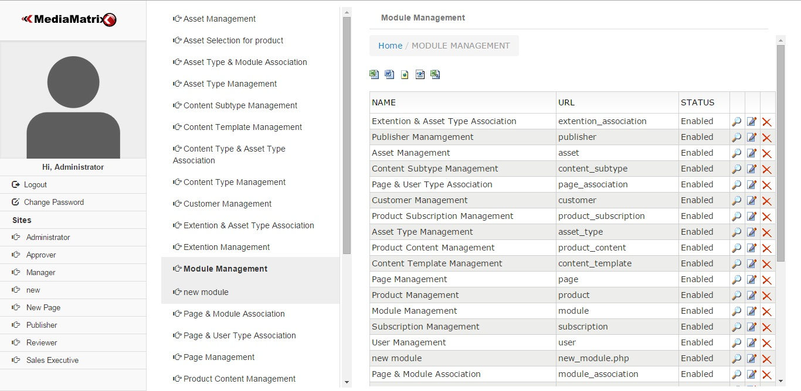

Figure 4.3.6.3

## 4.3.7 Page and Module Association

Main

This is important feature of site which controls the page and module association. Admin will have control on all modules. Manager can have some of modules. Publisher can access only those modules which require publishing contents.

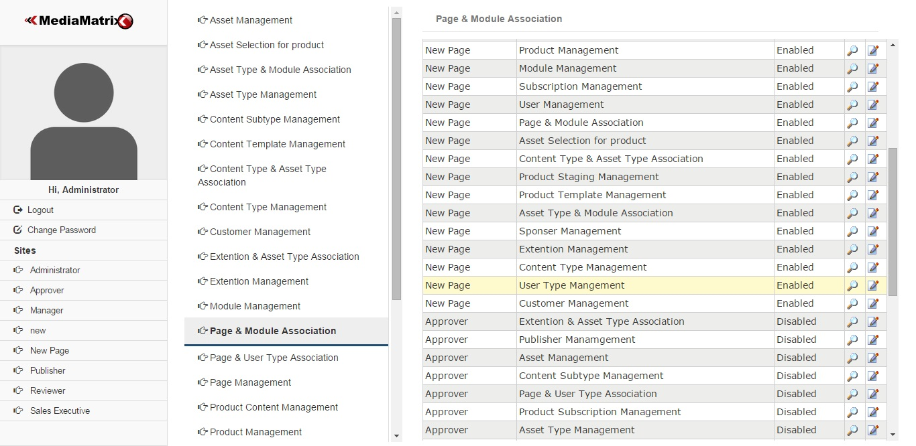Figure 4.3.7.1

## 4.3.8 Asset Type Management

Main

Asset type management is used to manage asset types as shown in below figure.

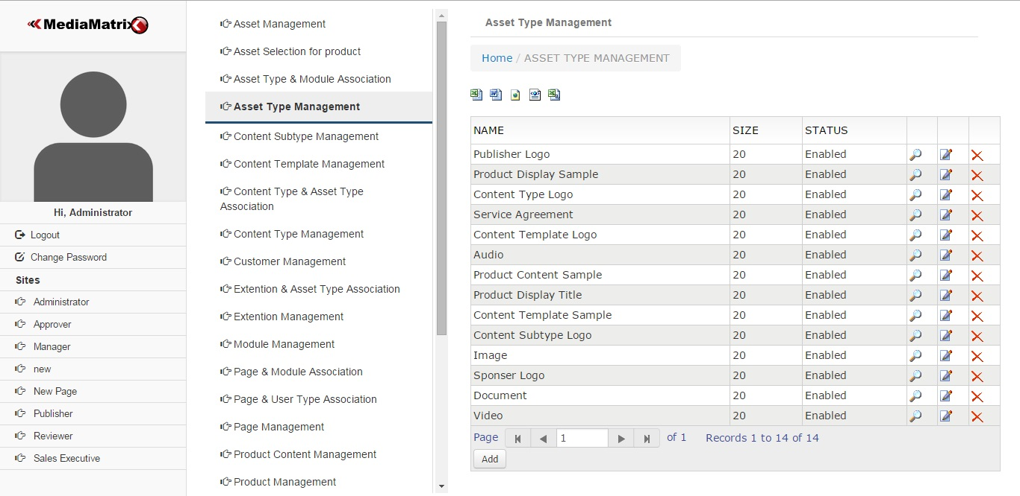

Figure 4.3.8.1

View / Add / Edit / Display

Asset type management also provided with view, add, delete and edit facility as shown in below figure.

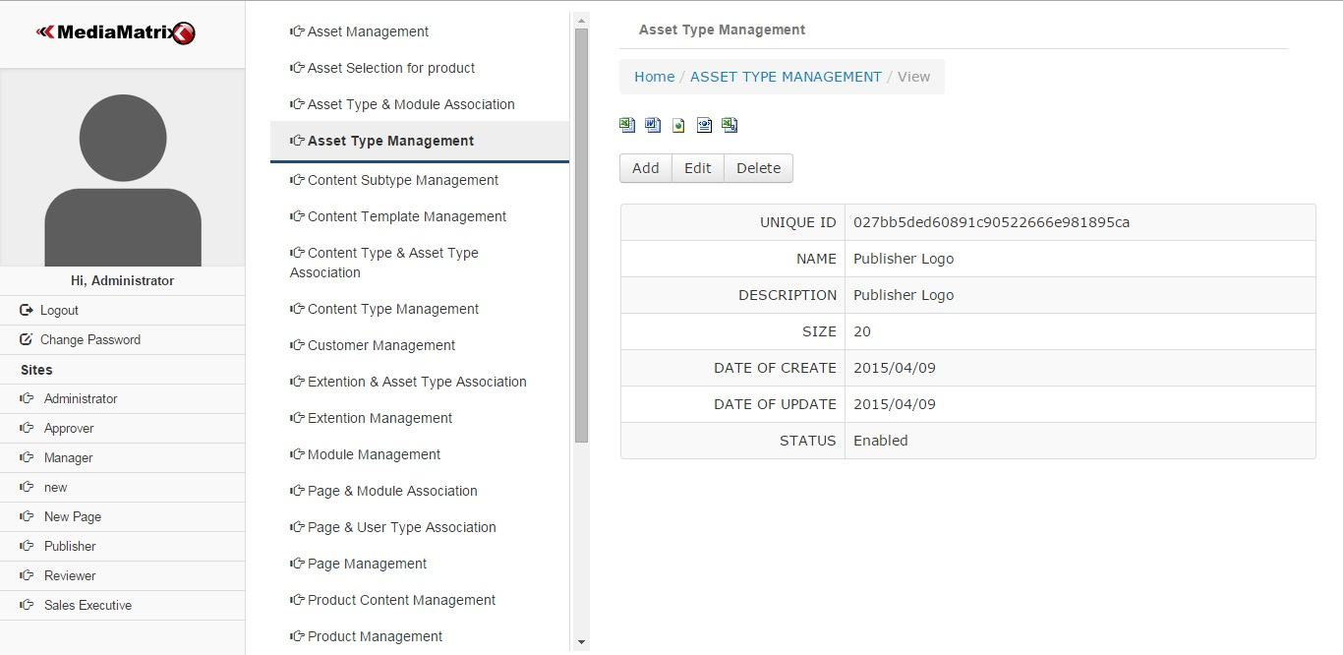

Figure 4.3.8.2

## 4.3.9 Asset Management

Main

Asset can be managed by using asset management. The actual asset is to be adding here.

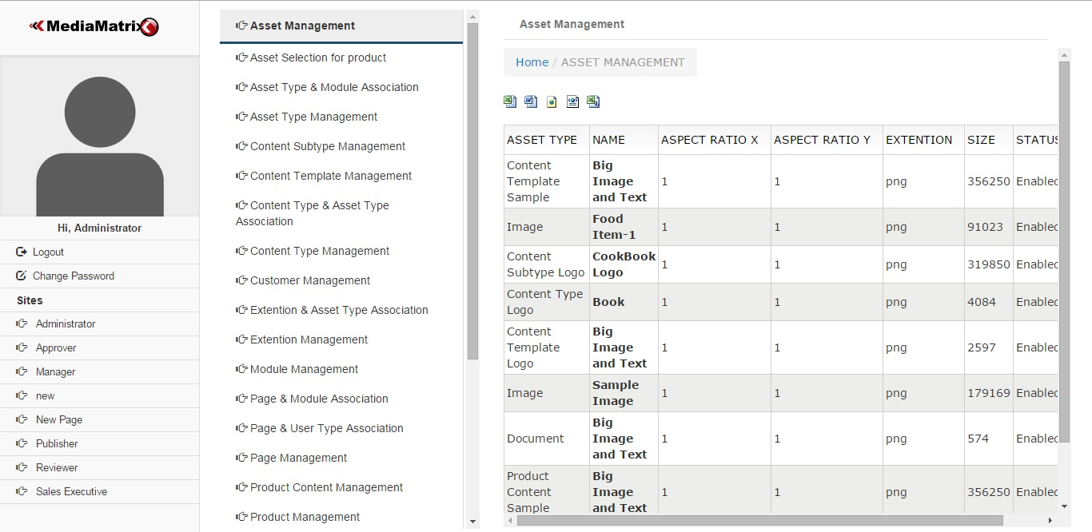

Figure 4.3.9.1

View Asset

Asset can be viewed by using view asset feature as shown in below figure.

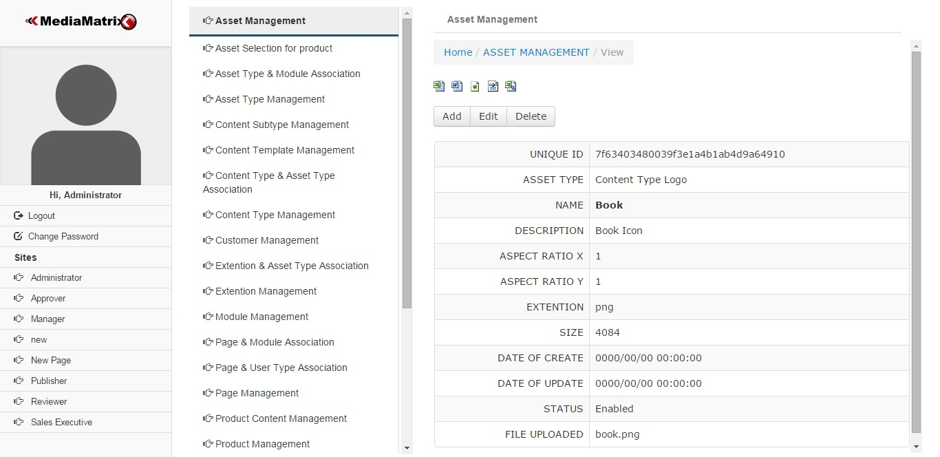

Figure 4.3.9.2

Add Asset

Add asset is used to adding new asset as shown in below figure.

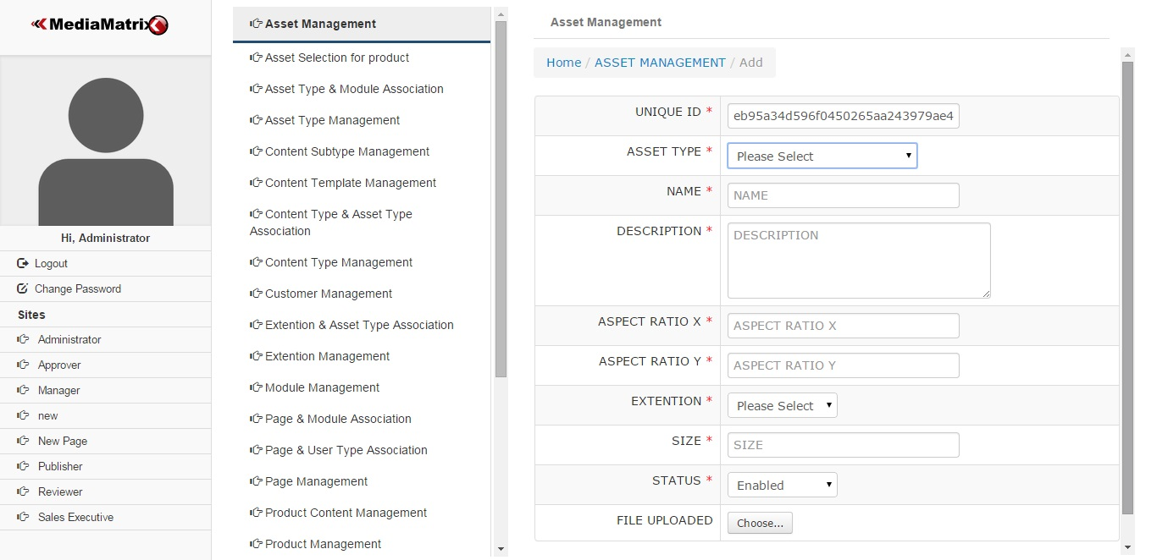

Figure 4.3.9.3

This shows that assets are derived from asset type in below figure.

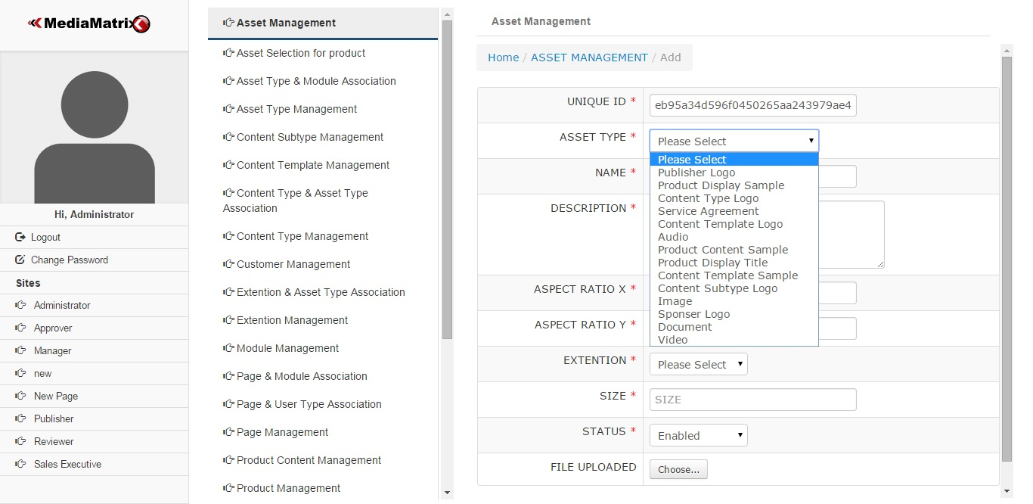

Figure 4.3.9.4

## 4.3.10 Asset Type and Module Association

Main

Asset type and module association is important feature of site. Restriction for asset on module can be put by using this association.

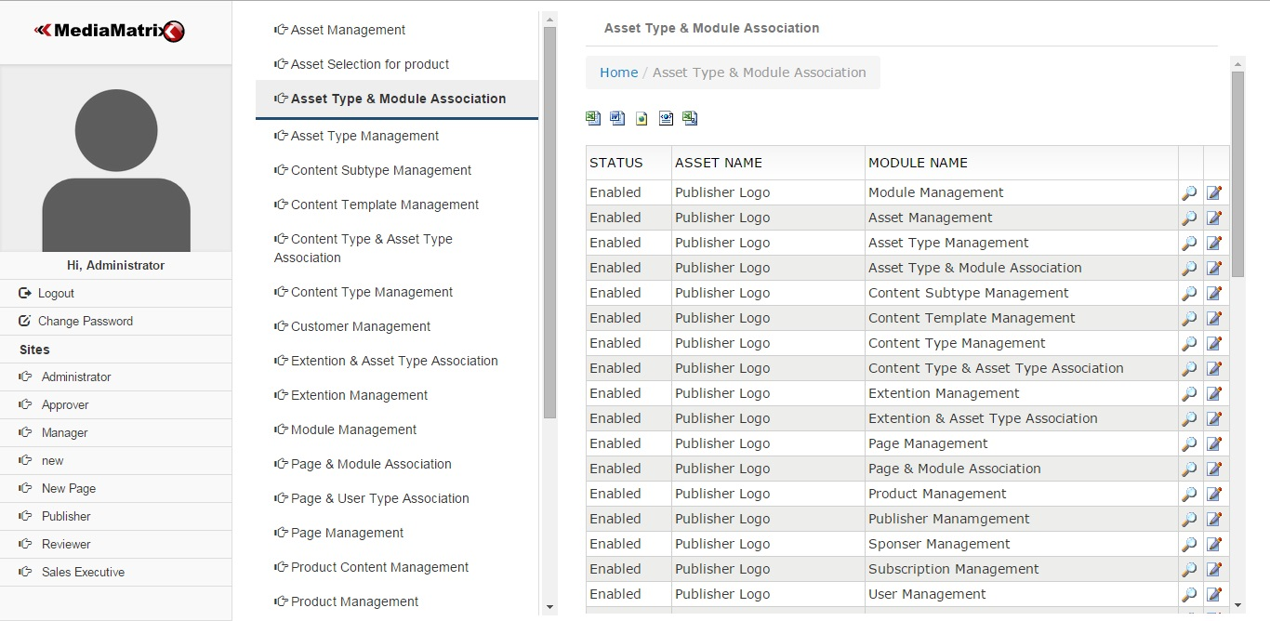

Figure 4.3.10.1

View / Edit

Asset type and module association can be viewed and edit as shown in below figure.

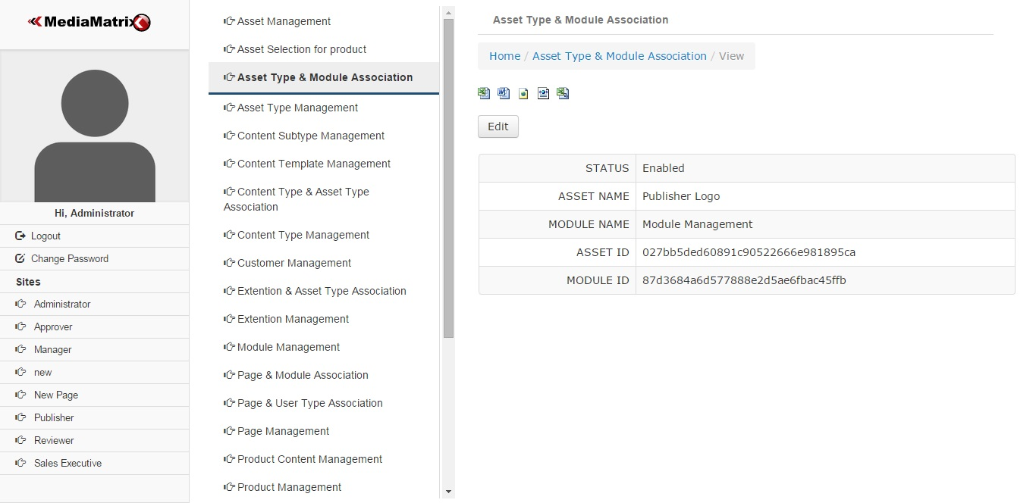

Figure 4.3.10.2

## 4.3.11 Extension Management

Main

Extension can be managed by using extension management as shown in below figure.

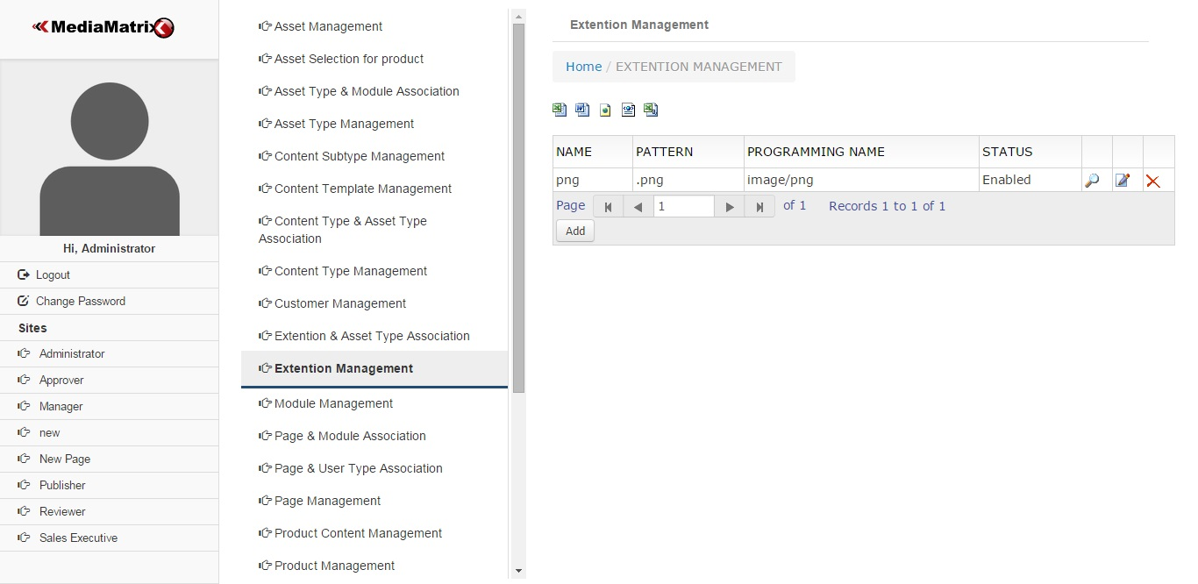

Figure 4.3.11.1

View Extension

View feature to view extension details as shown in below figure.

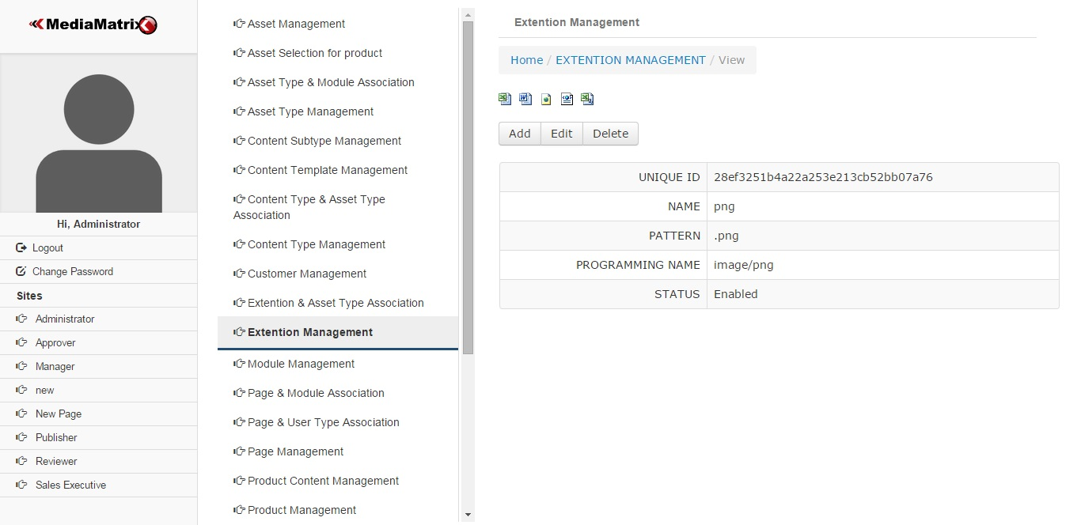

Figure 4.3.11.2

Add Extension

Add extension is used to add new extension. This requires details such as name, pattern, programming name and status as shown in below figure.

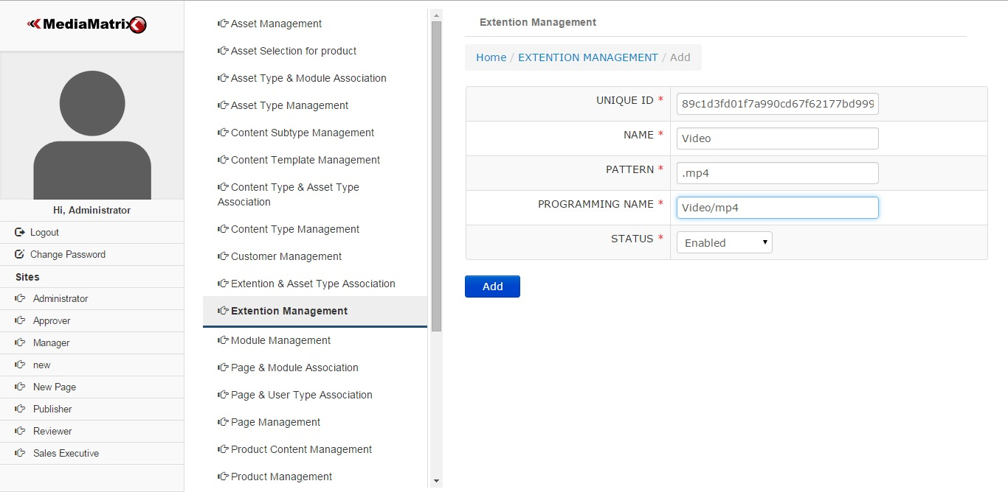

Figure 4.3.11.3

Display Added Extension

Display newly added extension named Video of pattern .mp4 as shown in below figure.

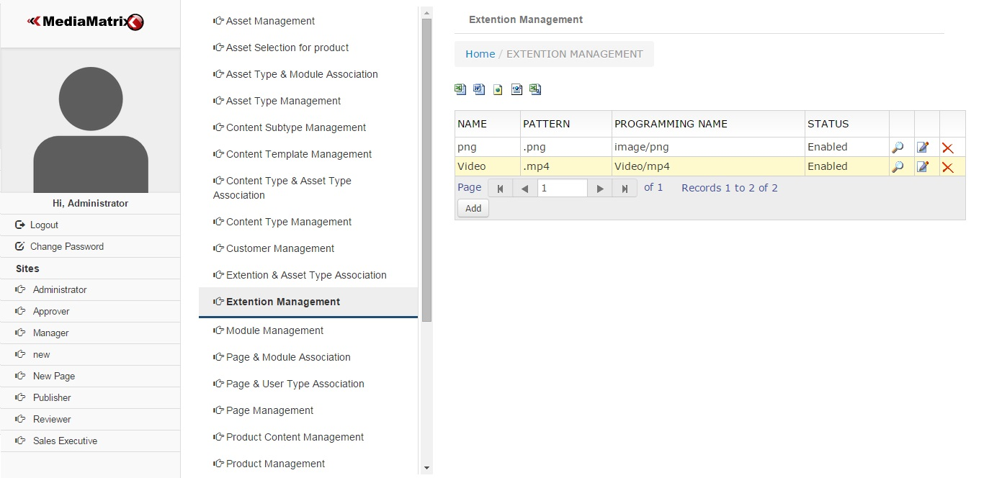

Figure 4.3.11.4

## 4.3.12 Extension and Asset Type Association

Main

Extension an asset type association is important feature of site. This controls the asset associated with extensions. For images extension .mp4, .mp3 etc are restricted that can be control by using feature as shown in below figure.

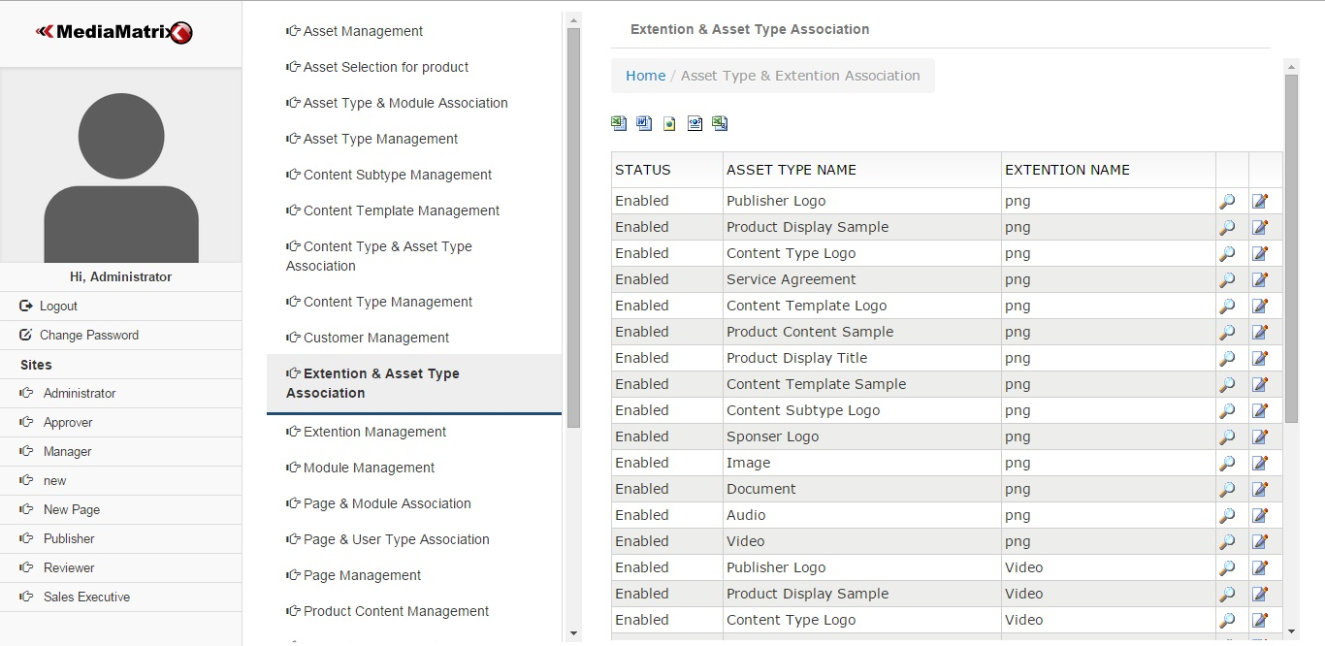

Figure 4.3.12.1

View Extension and Asset Type Association

Extension and Asset type association can be viewed as shown in below figure.

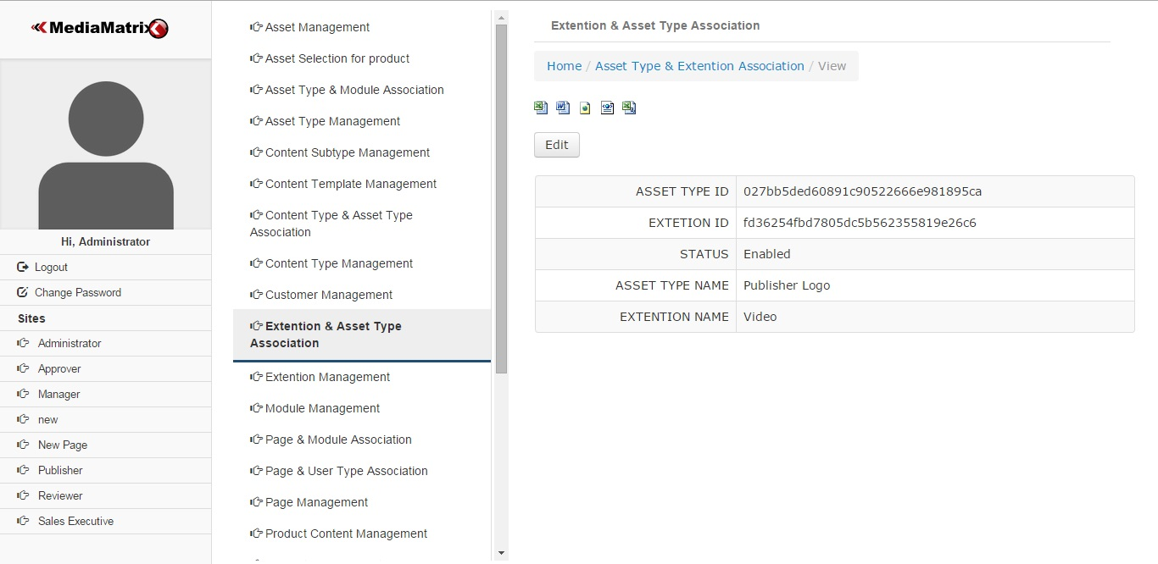

Figure 4.3.12.2

## 4.3.13 Content Type Management

Main

Content Type Management is used to manage contents as shown in below figure.

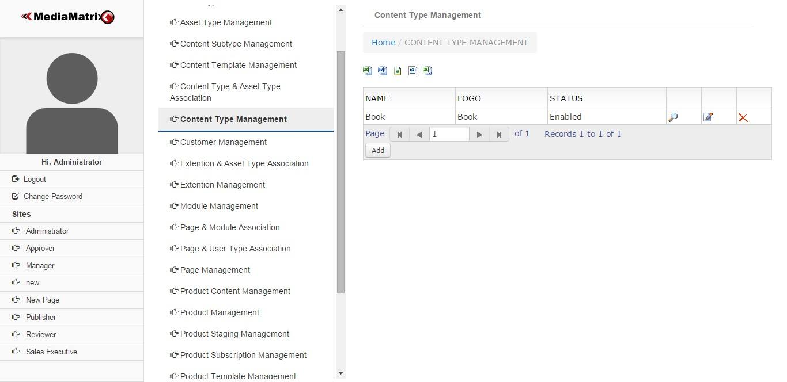

Figure 4.3.13.1

Add Content Type

Add Content type is used to add new content as shown in below figure.

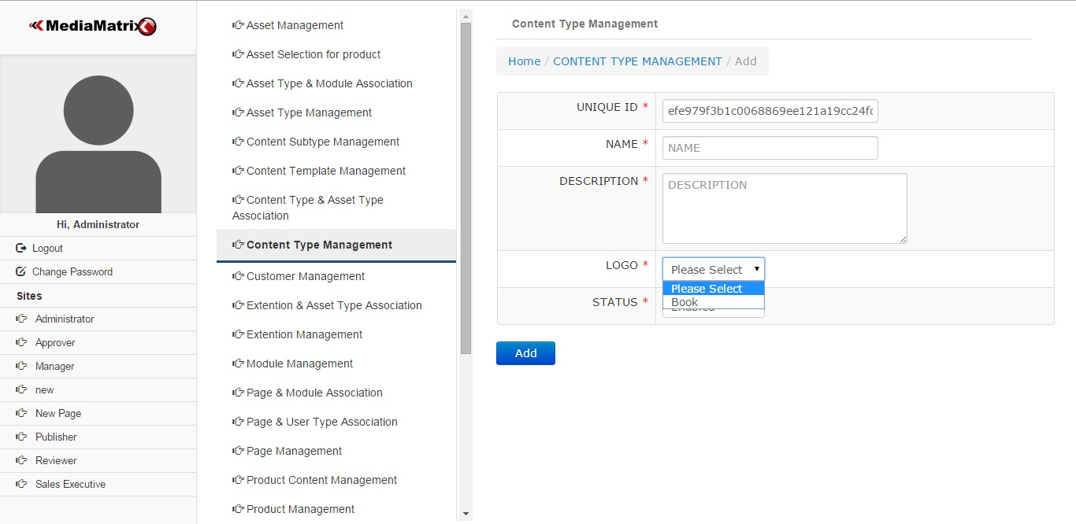

Figure 4.3.13.2

## 4.3.14 Content Subtype Management

Main

Content Subtype is derived from content type as shown in below figure. For example if content type is book then content subtype can be cook book, education book, general knowledge book etc.

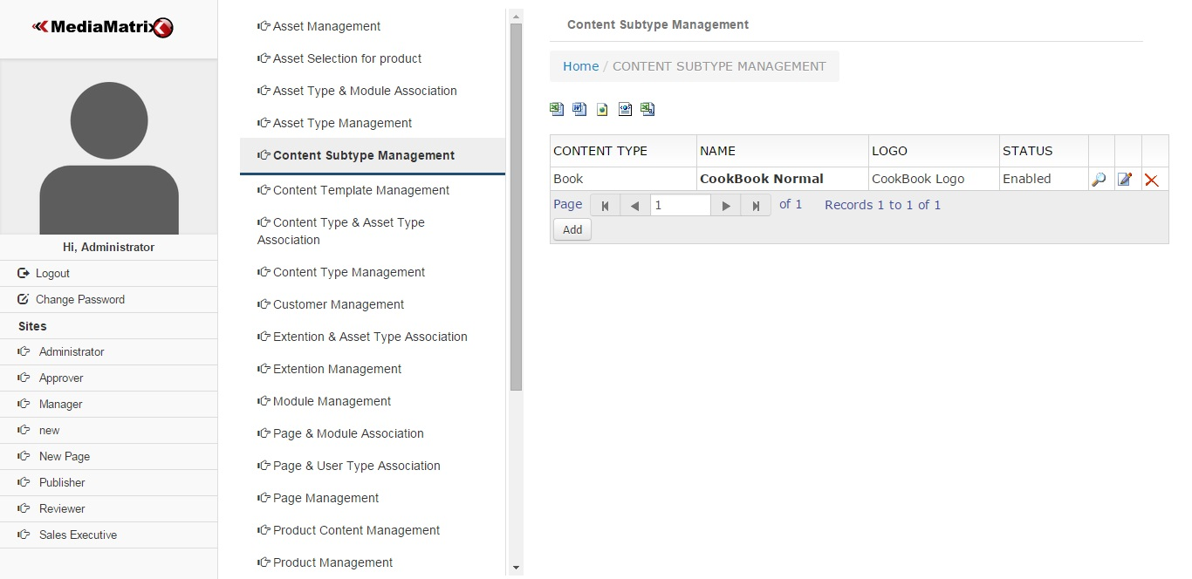

Figure 4.3.14.1

View Content Subtype

Content subtype can be viewed by using content subtype feature as shown in below figure.

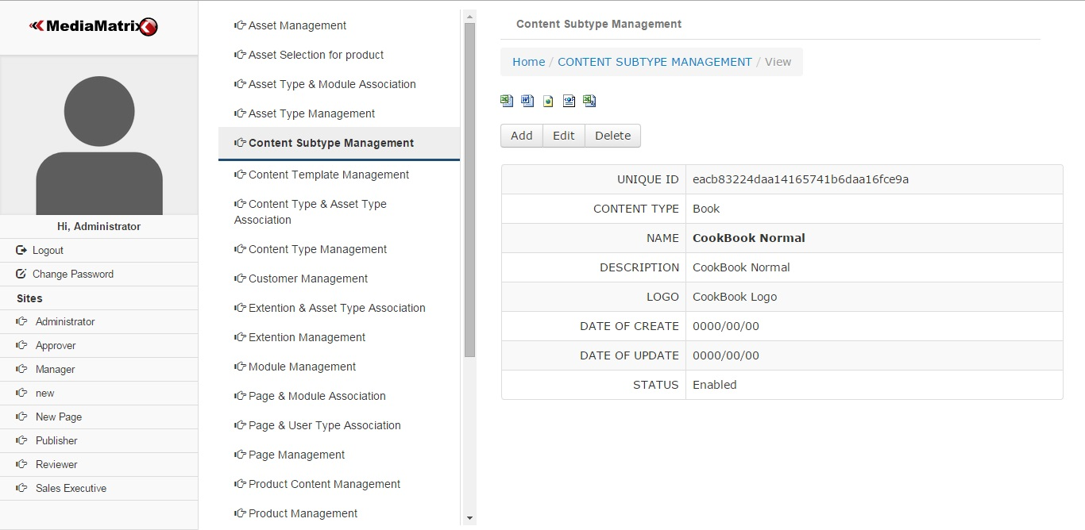

Figure 4.3.14.2

Add Content Subtype

Add Content Subtype is used to add new content subtype as shown in below figure.

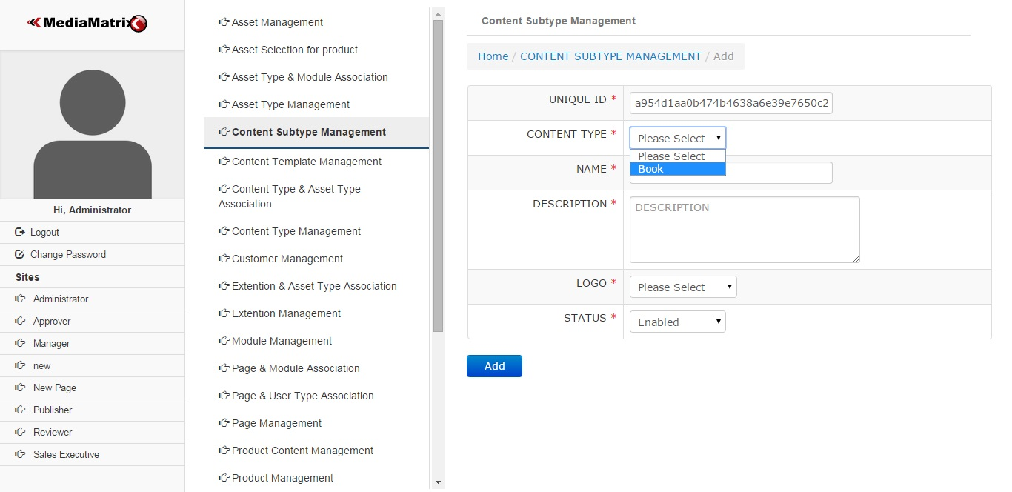

Figure 4.3.14.3

## 4.3.15 Content Template Management

Main

Content Template can be managed through content template management as shown in below figure. Content template management would be one html file.

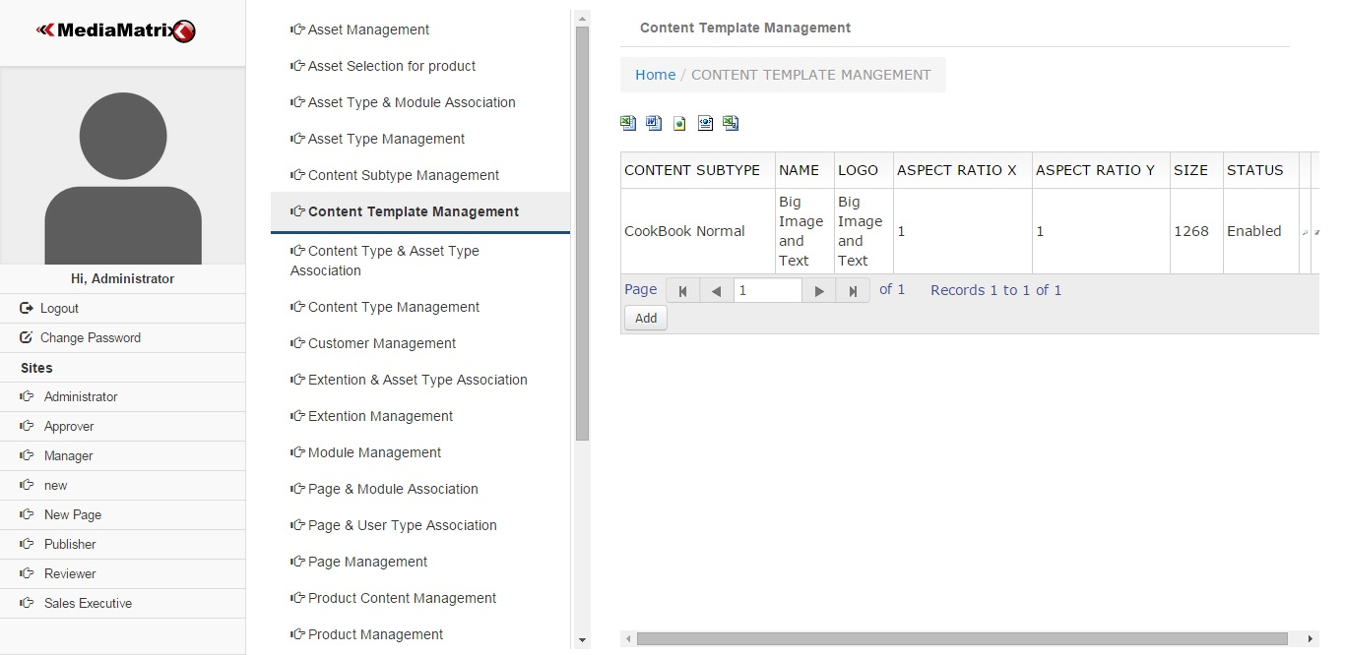

Figure 4.3.15.1

Add / Edit / Delete

Content Template provided with add, edit and delete features.

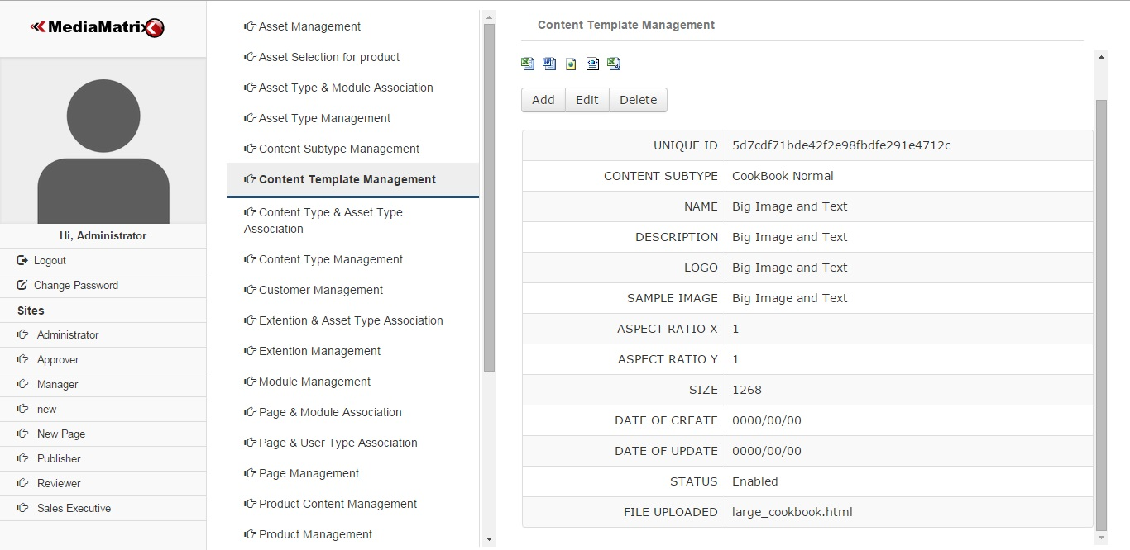

Figure 4.3.15.2

Add Content Template

Add content template is used to add new content template as shown in below figure.

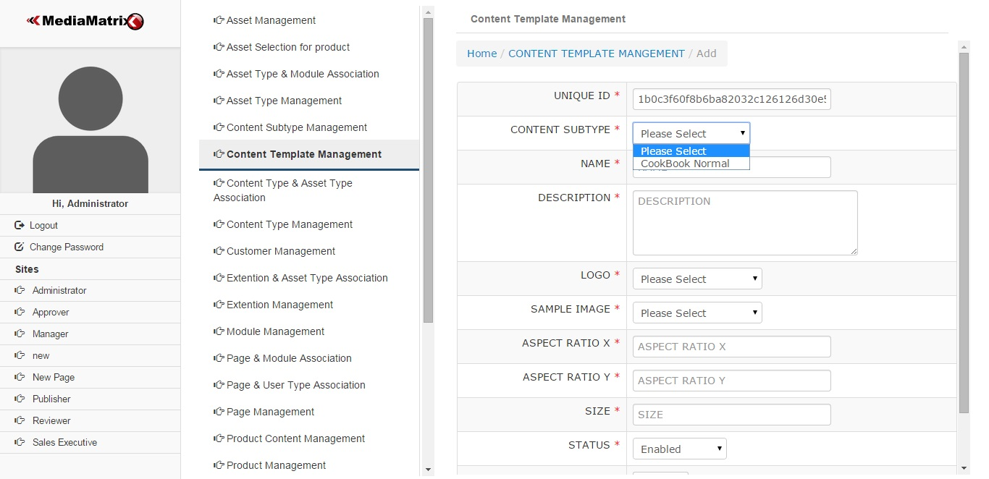

Figure 4.3.15.3

The last detail file uploaded in below figure for adding new content template requires html to be upload.

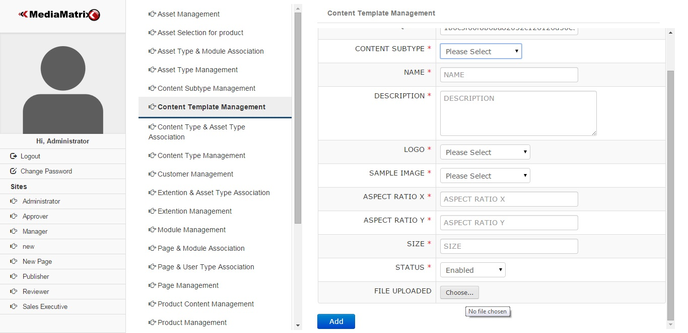

Figure 4.3.15.4

## 4.3.16 Publisher Management

Main

Figure for managing publishers.

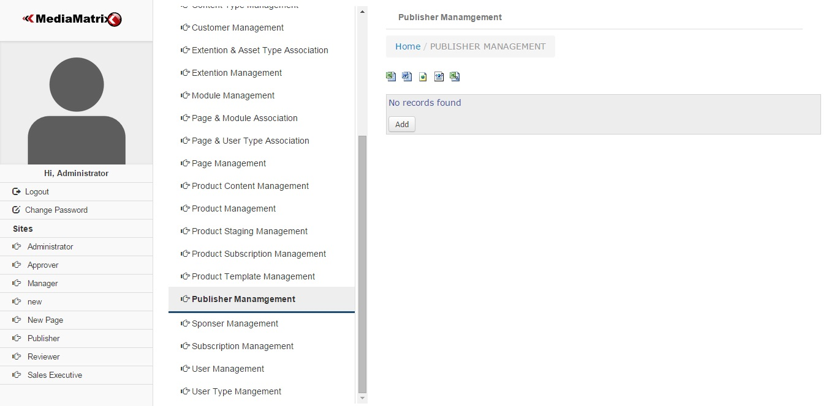

Figure 4.3.16.1

Add Publisher

Add new publisher requires details about publishers as shown in below figure.

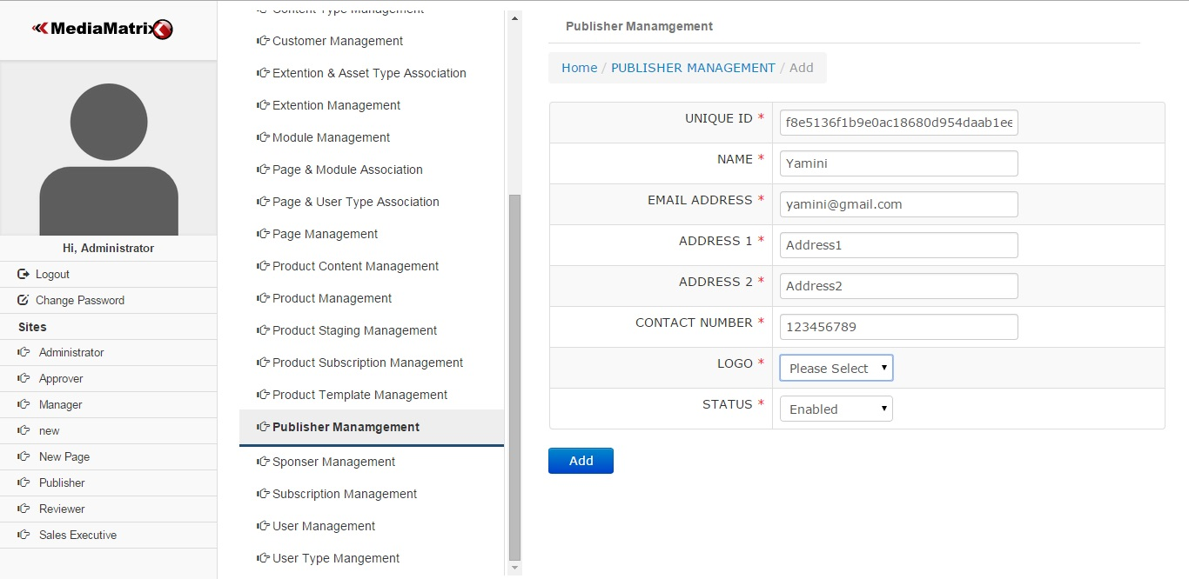

Figure 4.3.16.2

## 4.3.17 Sponsor Management

Main

Sponsor can be view, add ,delete, edit by Sponsor management.

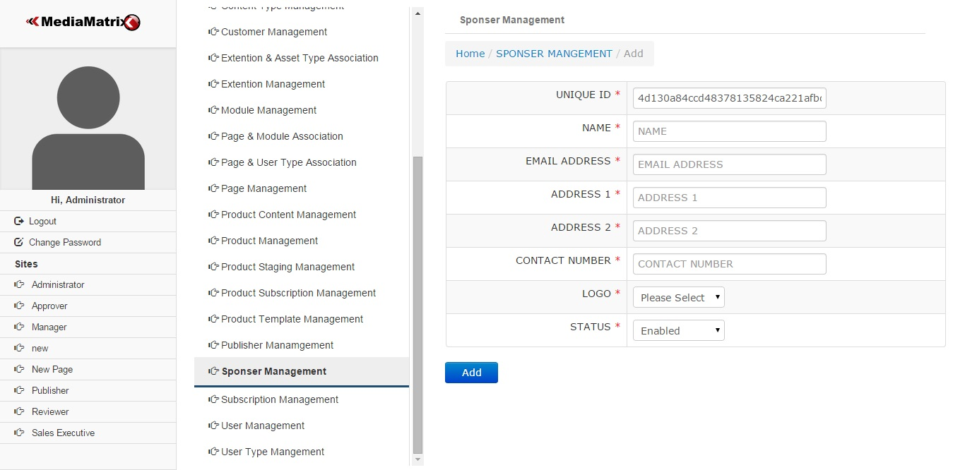

Figure 4.3.17.1

## 4.3.18 Subscription Management

Main

Subscription is used to manage amount, duration details as shown in below figure.

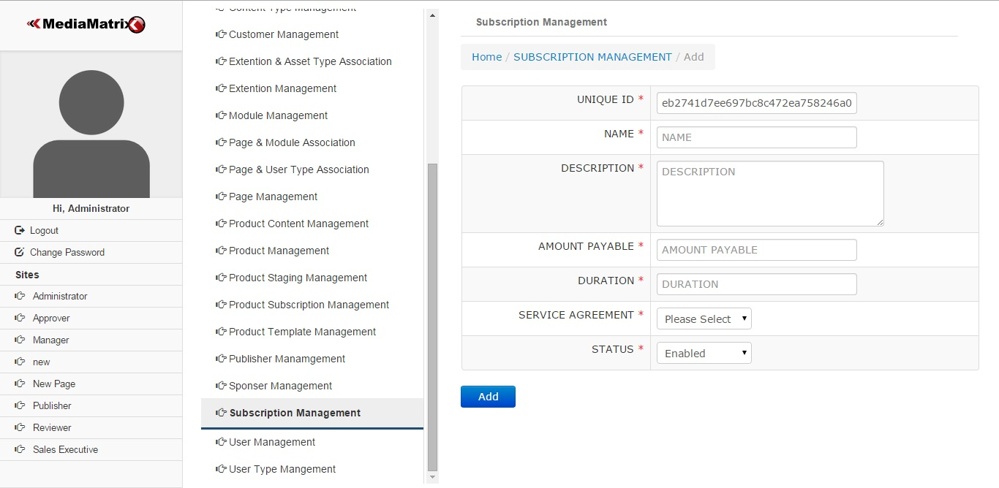

Figure 4.3.18.1

## 4.3.19 Asset Selection for Product

Main

Asset selection for product

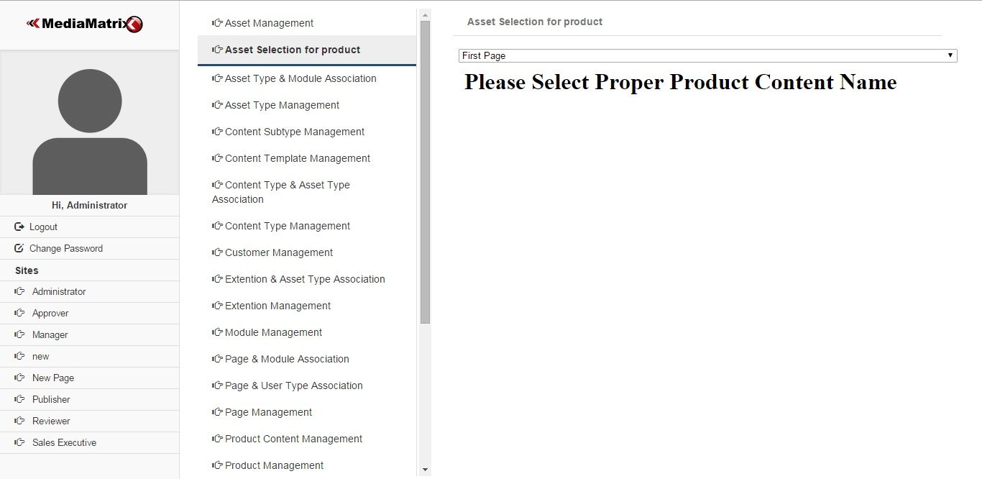

Figure 4.3.19.1

Asset selection for product

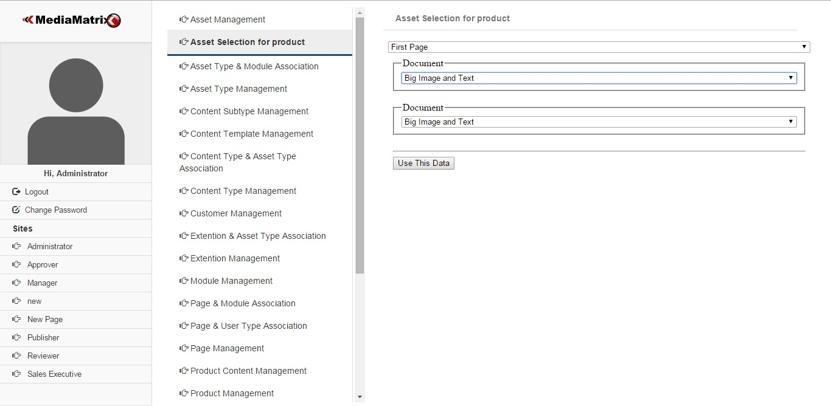

Figure 4.3.19.2

Asset selection for product

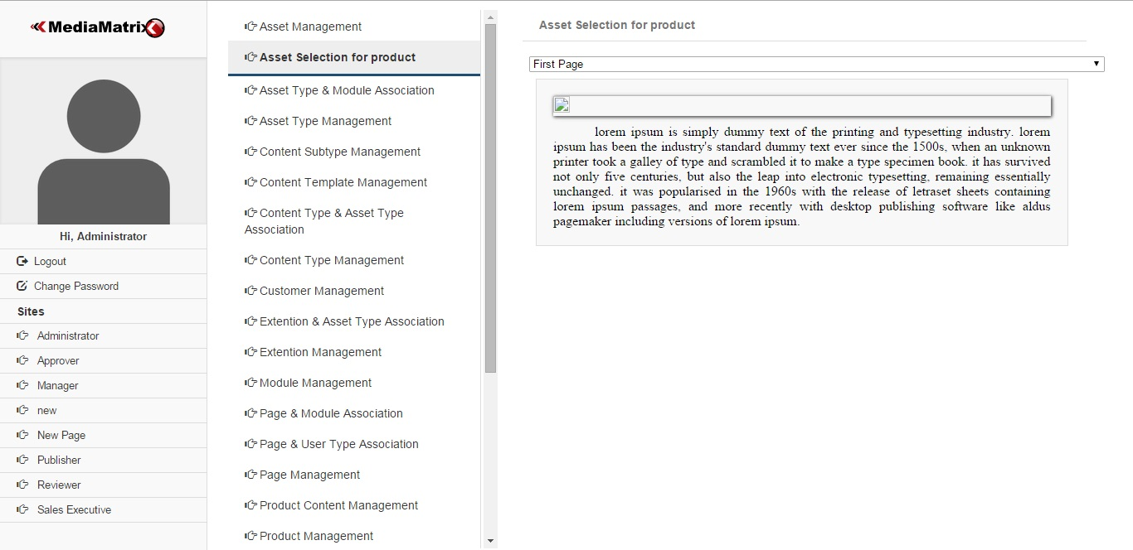

Figure 4.3.19.3

## 4.3.20 Product Content Management

Main

Product Content Management

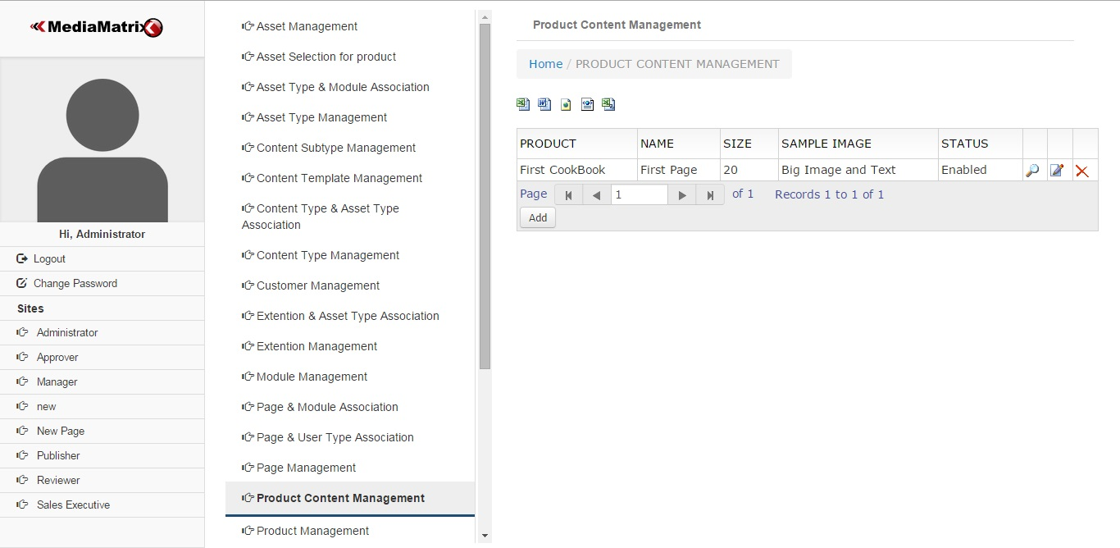

Figure 4.3.20.1

## 4.3.21 Product Management

Main

Product Management

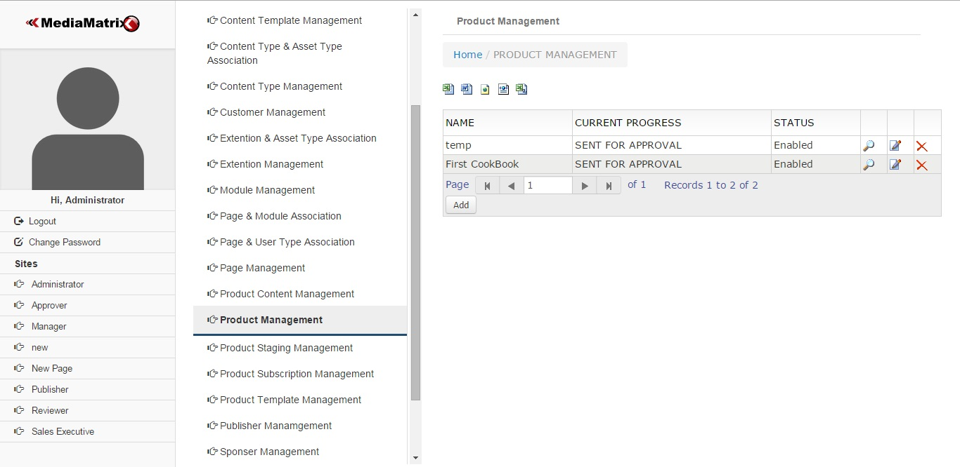

Figure 4.3.21.1

## 4.3.22 Product Subscription Management

Main

Product Subscription Management

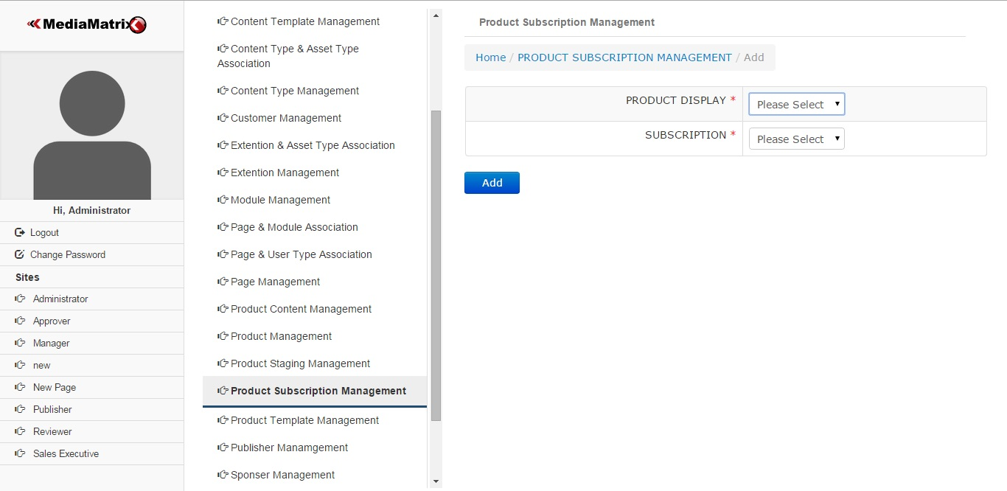

Figure 4.3.22.1

## 4.3.23 Product Template Management

Main

Product Template Management

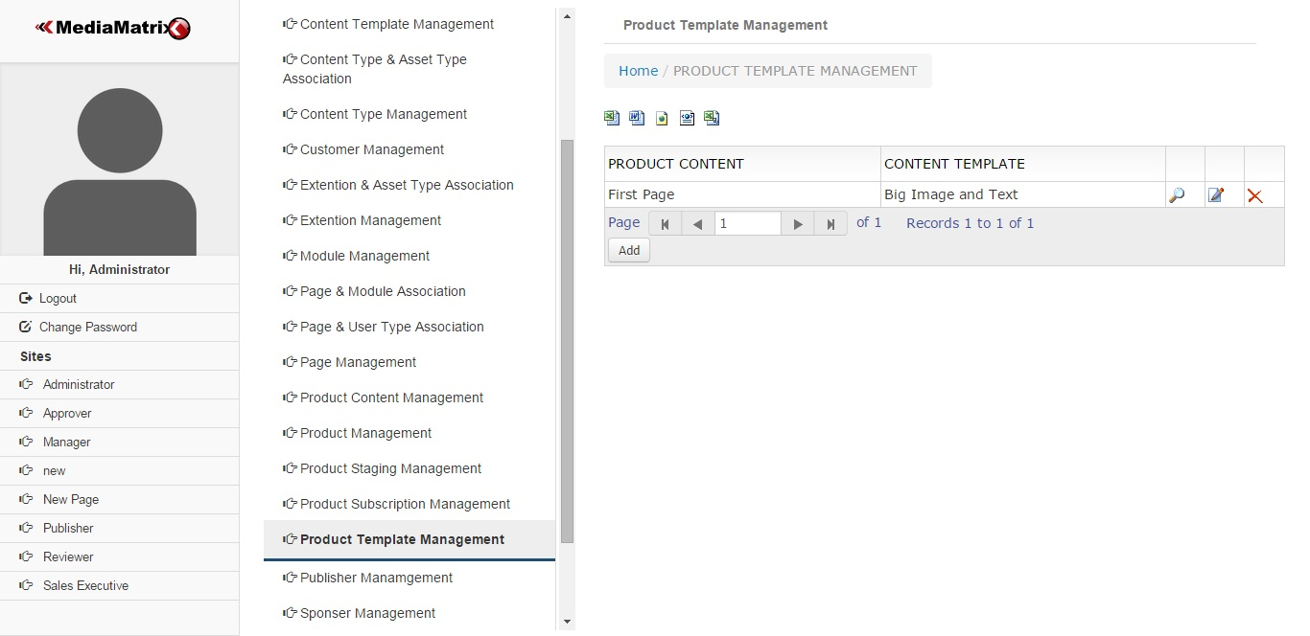

Figure 4.3.23.1

View / Add / Edit / Delete

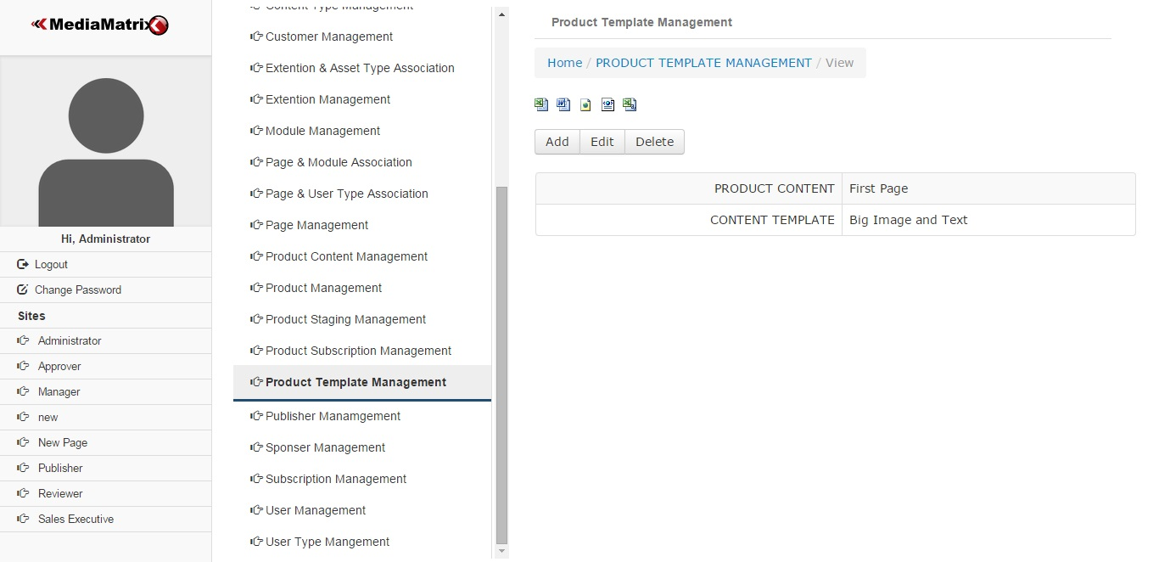

Figure 4.3.23.2

## 4.3.24 Product Staging Management

Main

Product Staging Management

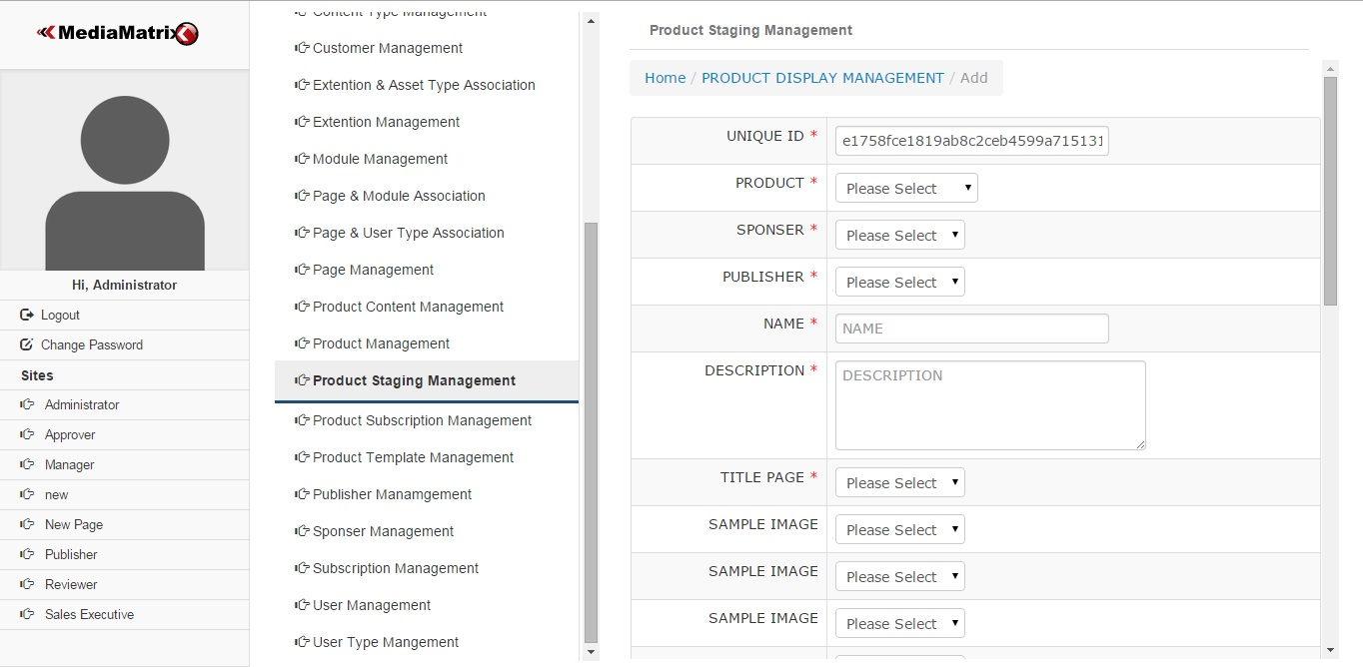

Figure 4.3.24.1

## 4.3.25 Manager Dashboard

Main

Manager Dashboard

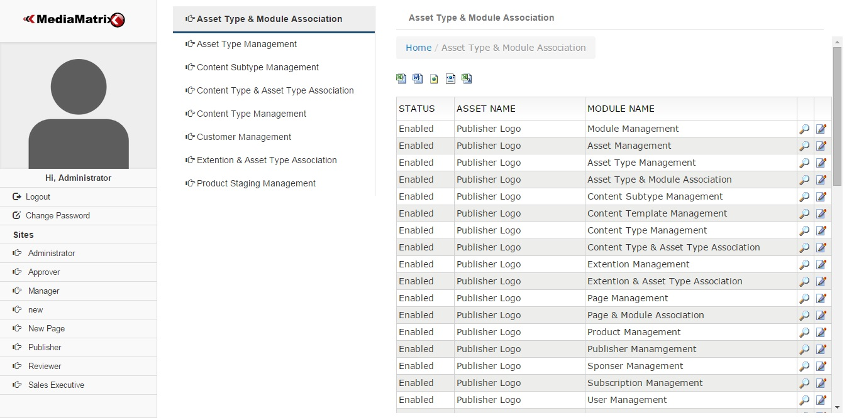

Figure 4.3.25.1

## 4.3.26 Sales Executive Dashboard

Main

Sales Executive Dashboard

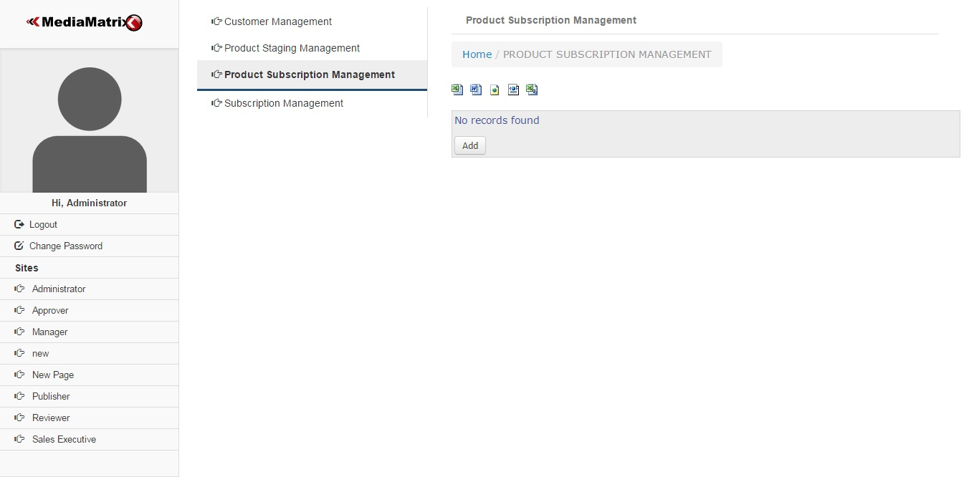

Figure 4.3.29.1

**Chapter 5**

# Result and Future Scope

Result

This project is an apparent solution to the problems faced by the organizations in generating and publishing content. The solution is to provide the coupling facility between the tools of generating and publishing, which in turn proposes the new challenges that are related to cross domain functionality, and are by nature hard to accomplish or at least not achievable without complex and sophisticated solutions. The solution is to provide the framework that does the publishing and generation for us. And this solution can be converted into the need if implemented properly. This solution is focused on creating online framework that provides the means of generating interactive content and mechanism to publish the content over the heterogeneous platforms ranging from formal desktop environments to mobile application. This means that the publishing party would provide the source content as input and views that are compatible with the multiple platforms and environments will be available as output. This solution is made from the ground up with the latest technology available and hence it keeps the door for the expansion and extension open. And hence it is more preferable and economical. Also the published content is compatible with the majority of the platforms ranging from desktop systems to the Sandboxed Mobile Application environment. Also the system is capable of publishing content that target device can cache offline. And hence eliminate the need of the continuous communication with our server. The system is accessible from the web enabled device and would have group of users each with different access rights and set of primitive action and responsibility. And according to the criterion set by us, users will be able to access the content. This provision of the content access will be subject to the service agreement which can be decided, and are subject to change or replace. The system can be extended to publish the content in multiple languages depending on the region of their deployment. This enables us in acquiring the variety of consumer from wide demographic regions.

Future Scope

Release the proposed system at the completion of major project under semester 8.

**Chapter 6**

**References**

References

1. www.wikipedia.com